Effect of hydrothermal time on the growth of ZnO nanorods on Printed Circuit Board substrates
Hanh Hong Mai*, Trong Tam Nguyen
Faculty of Physics, VNU University of Science, 334 Nguyen Trai, Hanoi, Vietnam
* Corresponding author, email: hanhhongmai@hus.edu.vn, phone: +84 967292460, ORCID id: 0000-0002-5924-5112

Abstract
We report the direct growth of high-quality, high-density and well-aligned ZnO nanorods on cost-effective printed circuit board substrates (PCBs) by a seedless hydrothermal method. It was shown that by implementing a galvanic cell structure in a saturated aqueous solution of zinc nitrate hexahydrate (Zn[NO3]₂·6H₂O) and hexamethylenetetramine (C₆H₁₂N₄), it can support the vertical grown of ZnO and significantly reduce the hydrothermal time. The effect of hydrothermal time on the surface morphology and the crystallinity of the synthesized ZnO nanorods were studied and discussed to clarify the growing mechanism of ZnO NRs by using scanning electron microscopy (SEM), X-ray diffraction (XRD), Raman, and photoluminescence spectroscopy (PL).
Keywords: ZnO nanorods, printed circuit board (PCB), hydrothermal method.

Introduction
In recent years, with the rapid development of miniaturized devices, the controllable synthesis and assembly of one-dimensional nanostructures such as nanowires, nanorods, and nanotubes into functional devices have attracted a lot of attention [1–5]. Zinc oxide (ZnO), a wide band gap (3.37 eV) semiconductor with large exciton binding
energy (~60 meV), has been considered as one of the most important semiconductor materials due to its wide range of applications in dye-sensitized solar cells, chemical and biological sensors, piezoelectric, and thermoelectric devices [6–10]. In those devices, ZnO nanorods can be grown on a number of surfaces such as insulating sapphire [11] and glass [12] or semiconducting Si [13] and GaN [14]. However, the poor conductivity of these substrates might limit their applications in some electronics and optoelectronics devices. Therefore, synthesizing ZnO NRs on a metal surface are preferable in manufacturing miniaturized device.
Among many conducting substrates, printed circuit board (PCB) containing a thin cooper layer on top of insulating fiber glass is ideal for electrical and thermal conductance due to its good conductivity. However, due to the big lattice mismatch between ZnO and copper, it is difficult to grown high-quality, and vertically aligned ZnO NRs on PCBs. Furthermore, PCBs can withstand with rather low temperature, this leads to the difficulty in forming a ZnO crystal seed layer to assist the vertical growth of ZnO NRs. It is due to the fact that the formation of ZnO crystal seed layer is normally required a high temperature of annealing. As a result, the fabrication of high-quality, and vertically aligned ZnO nanorods on PCBs still remains a complex task. In fact, several techniques have been developed to overcome this issue. For example, Chew et al. developed a method to grown high density ZnO nanowires on PCB substrates using hydrothermal method at low temperature for memory resistor application [15, 16]. In this approach, a seed layer was deposited on the PCB substrate by using Joule heating method prior to the hydrothermal growth of ZnO nanowires. The method requires a complex, multi-step synthesis which needs an external current applied on the copper thin layer for seed layer preparation. Errico et al. and Arrabito et al., on the other hand, reported their success in synthesizing ZnO nanowires on PCB substrates using an additional adhesion layer [17], or a thin chromium film [18]. The fabricated ZnO exhibited a good vertical alignment and adhesion. However, depositing an additional layer on top of the PCB substrates may leads to a multi-step synthesis which may introduce impurities, and exert a strong influence on the adhesion of ZnO nanostructures to the underlying substrates. More recently, Pham et.al reported their work on seedless hydrothermal synthesizing ZnO NRs by implementing a galvanic cell structure in non-saturated equimolar aqueous solutions of zinc nitrate hexahydrate (Zn[NO₃]₂·6H₂O) and hexamethylenetetramine (C₆H₁₂N₄) [19]. In this work, the galvanic cell structure created between a scarifying Al thin film and PCB substrate assisted the formation of a buffer layer on top of the substrate. As a result, ZnO NRs can grow directly on the PCBs without the adhesion of a seed layer. However, the vertical alignment of the as-grown ZnO NRs is still poor in comparison with that of seeded hydrothermal method. Another approach to grow ZnO NRs on conductive substrates is to synthesize them under saturated solution of Zn[NO₃]₂·6H₂O and C₆H₁₂N_{4.} It has been shown that under a saturated nutrition solution, a buffer layer was also formed on the substrates at the beginning of synthesizing process to help releasing the elastic strain resulted from the lattice mismatch between ZnO and the conduction substrates. As a result, ZnO NRs can grow directly on conductive substrates without implementing a seed layer. However, the drawback of this method is the long hydrothermal time e.g. 7h [20], 13h [21, 22].
In this work, we report a success in synthesizing vertically aligned ZnO NRs on PCBs by implementing a gavalnic cell structure under a saturated solution of zinc nitrate hexahydrate (Zn[NO₃]₂·6H₂O) and hexamethylenetetramine (C₆H₁₂N₄). We proved that by combining these two seedless hydrothermal approaches, ZnO NRs can be grown on PCBs with high density and high crystallinity. Most importantly, this combination supported the vertical alignment of ZnO NRs while reduced the hydrothermal time. We also study the effect of hydrothermal time on the surface morphologies, the preferable growth orientation and the crystallinity of the as-grown ZnO NRs was studied, and discussed in detail to clarify the growing mechanism of ZnO NRs.
2. Experiment
Sample preparation
ZnO NRs were grown on PCB substrates by a hydrothermal growth technique. The substrates were first ultrasonically cleaned in acetone, ethanol, and deionized (DI) water for 5 min each. In order to create a galvanic cell structure, Al foil was used to cover the edge of the substrates. The uncovered area is where ZnO nanorods would be grown (Fig. 1). In order to prevent bubbles trapped on the surface, which may lead to the non-uniform growth of ZnO NRs on the large-area surface during synthesis, a microscale rough surface of the PCB substrates was produced by rubbing them with sandpaper prior to the creation of the galvanic cell. Such a procedure can help increase the contact area of the surface and adhesion of ZnO NRs.
Afterwards, the as-prepared substrates were dipped into an equivalent saturated nutrition solution of 80mM zinc nitrate hydrate (Zn(NO₃)₂ · 6H₂O) and of 80mM hexamethylenetetramine (C₆H₁₂N₄) (Sigma Aldrich: http://www.sigmaaldrich.com). The substrates were immersed in the solution with the temperature maintained at 90ºC. The substrates were again rinsed with DI water to remove residual salts from the surfaces before being air-dried. To study the influence of hydrothermal time on the surface morphology, preferable growth orientation and the crystallinity of the as-grown ZnO NRs, the hydrothermal growth of the ZnO on PCB substrates were carried out with different duration time of 0.5h, 1h, 3h, 5h, 7h.
Characterization
The morphology of the sample surface was examined by scanning electron microscopy (SEM) (Nova NanoSEM 450). The crystallinity of the ZnO NRs was characterized by X-ray diffraction (X-ray Powder Diffraction System D5000 Siemens) and Raman spectroscopy (Labram Hr800, Horiba). The PL spectra of the ZnO NRs were collected by exciting the samples with 325 nm He-Cd laser which is one of the most common light sources for the PL investigation of ZnO NRs. The PL spectra were then recorded at room temperature before and right after treatment with glucose of the above-mentioned concentrations.
3. Results and Discussion
Surface morphologies and optical properties of the as-grown ZnO NRs
The chemistry of the hydrothermal growth of ZnO nanocrystals is well reported elsewhere [18, 23, 24]. Zinc nitrate salt provide ${Zn}^{2+}$ ions required for building up the ZnO NRs while hexamethylenetetramine hydrolyzes to produce formaldehyde and ammonia. Ammonia further hydrolyzes into ${OH}^{-}$and $NH_{4}^{+}$. The ${OH}^{-}$ion forms a complex compound with ${Zn}^{2+}$ and then it decomposes into ZnO under given reaction conditions. The chemical reactions are summarized as follows:
$$C_{6}H_{12}N_{4}+6H_{2}O⟶4NH_{3}+6HCHO$$
$${NH}_{3}.H_{2}O⟷NH_{4}^{+}+{OH}^{-}$$
$${Zn}^{2+}+2{OH}^{-}⟷Zn{(OH)}_{2}$$
$$Zn{(OH)}_{2}→ZnO+H_{2}O$$
The seedless hydrothermal growth of ZnO NRs on PCB substrates under saturated solution is depicted in Fig. 1. As seen in Fig. 1a, the Cu surface of the PCB substrate served as nucleation sites when substrate was immersed in the nutrition solution. The number of nuclei was proportional to the concentration of nutrition solution. In fact, when the number of ZnO nuclei was low, both the lateral growth and vertical growth could occur [19]. With the increasing amount of nucleation, the lateral growth could be suppressed. It is due to the fact that when the equimolar aqueous solution was saturated, the number of ion ${Zn}^{2+}$ and ${OH}^{-}$was drastically increased. This resulted in the significant enhancement of ZnO nuclei which then formed a thin layer of ZnO on the surface. This thin layer can act as a buffer layer to release the elastic strain resulted from the lattice mismatch between ZnO and the surface. After the formation of the buffer layer, the newly arrived ions could only be used to the growth of ZnO NRs because they had a bigger chance to reach the existing nanorods than to form the new nuclei on the substrate. Subsequently, ZnO NRs began to grow up along c-axis preferentially on the surfaces without strain and defect. With this hydrothermal approach, vertically aligned ZnO NRs can be obtained without implementing an additional ZnO seed layer.
It was well reported that the hydrothermal synthesizing of ZnO NRs under saturated solutions normally takes at least 7 hours, or up to 13 hours until the ZnO NRs reach the desirable size [18, 20, 21]. In order to significantly reduce the hydrothermal time, in this work a galvanic structure was employed by covering the edge of the PCB substrate with an Al foil. Due to the reduction potential difference between the Cu conductive layer and the Al layer, a contact potential was induced to create a bias. This bias boosted the nucleation of ZnO on the exposed Cu area. Herein, Al acted as a sacrificing anode, and lost electrons to develop positive charges Al³⁺ whereas the lost electrons moved to the PCB cathode. Subsequently, reduction reactions of dissolved oxygen (O₂ + 2H₂O + 4 e⁻ —› 4OH⁻) occurred on the PCB cathode that were followed by the formation of Zn(OH)₂. Again, solid ZnO nuclei were formed on the exposed Cu area of PCB by the dehydration of the Zn(OH)₂ hydroxide as seen in Fig. 1b. These chemical reactions under the saturated nutrition solution together with galvanic effect helped to grow vertically aligned ZnO NRs with high density in a short period of time.
The morphologies of the as-grown ZnO NRs with different hydrothermal durations of 0.5h, 1h, 3h, 5h and 7h are shown in Fig. 2. It can be seen that the ZnO NRs underwent a gradual morphological evolution with reaction time. After only 0.5h of hydrothermal duration well-aligned ZnO NRs with high density were already formed with the diameters ranging from 50 to 300 nm. However, the formation of the rod was not completed. When the hydrothermal time was increased up to 1h, the growth of ZnO NRs continued and resulted in a larger nanorod’s diameters. For longer hydrothermal time such as 3h and 5h, the formation of the rods was almost finished and the rods’ diameter could reach up to 500 nm. This result suggests that, with increasing duration of hydrothermal process, the rate of growth of ZnO NRs on PCB substrate increases. This is because of the availability of more nuclei on the surface of the NRs. When the hydrothermal time was long enough such as 7 hours, the structures were completely covered by another layer of ZnO. This is probably due the reaction time was long enough to create another buffer layer of ZnO on top of the as-grown ZnO NRs.

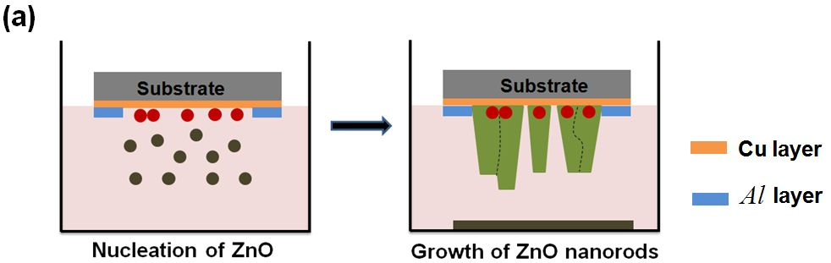

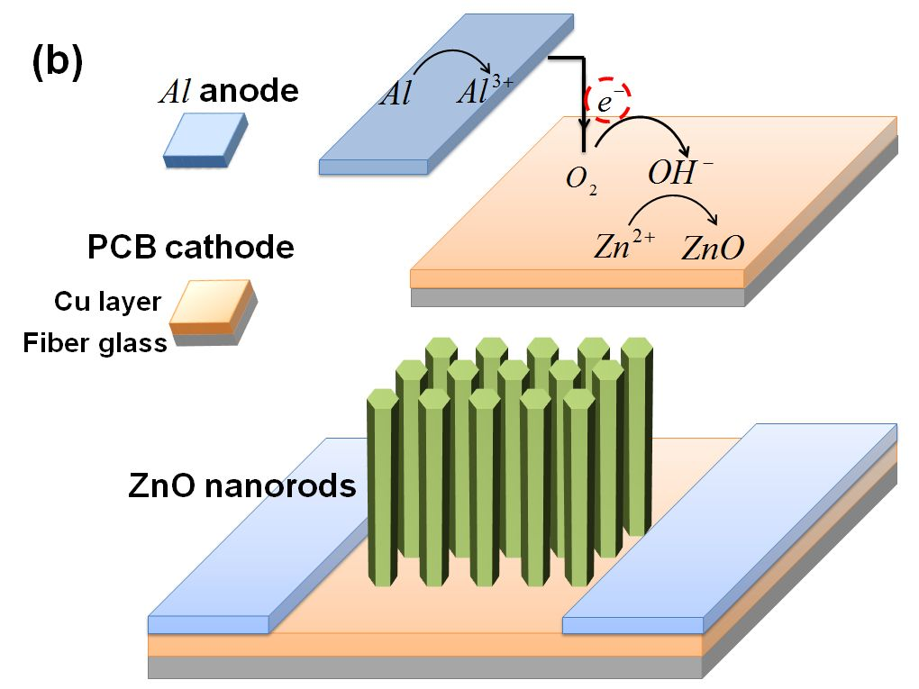
Fig. 1 Schematic diagram depicted seedless hydrothermal growth process of ZnO NRs grown on PCB substrate a) under a saturated nutrition solution, b) based on galvanic cell effect. Al is used as the sacrificing anode and PCB substrate is considered as the cathode
Similar results were also recognized from the Xray pattern. As can be seen in Fig. 3, the preferential growth of the ZnO NRs in the (002) direction is noticeable after only 0.5h of hydrothermal duration. When the hydrothermal time was increased further, the (002) direction became even more obvious compared to the (100) and (010) direction. The highest ratio between the (002) peak and two lateral peaks denoted the best vertical orientation was obtained with 5h of hydrothermal duration. The vertical orientation got worse in the case of 7h hydrothermal time which can be explained by the formation of a buffer layer on top of the as-grown ZnO NRs.
To study the effect of the hydrothermal hydrothermalh time on the crystallinity of the as-grown ZnO NRs, Raman and PL spectra were taken. Figure 4 shows the Raman spectra of the ZnO NRs samples, which exhibit main peaks at 98 cm⁻¹ and 437 cm⁻¹, corresponding to the optical phonon E₂ (low) and E₂ (high) of the ZnO, respectively [25–27]. The stronger and sharper the two peaks indicate the higher crystallinity of the as-grown ZnO NRs. The figure also denotes the best crystallinity was obtained with samples of 5h hydrothermal time.
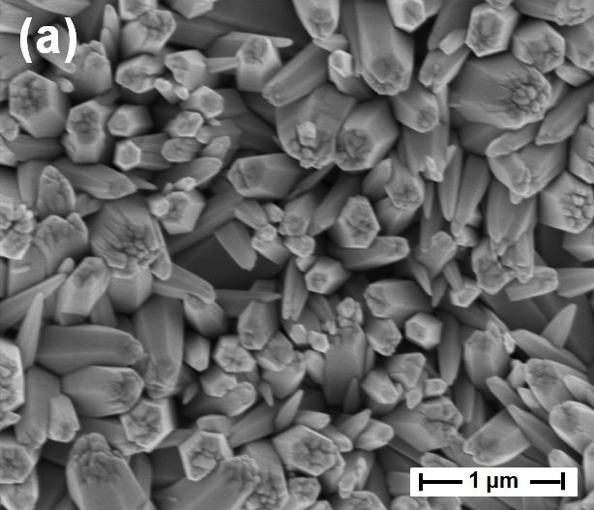 |  | 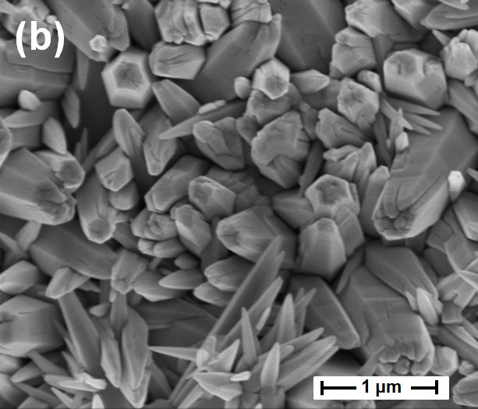 |  | 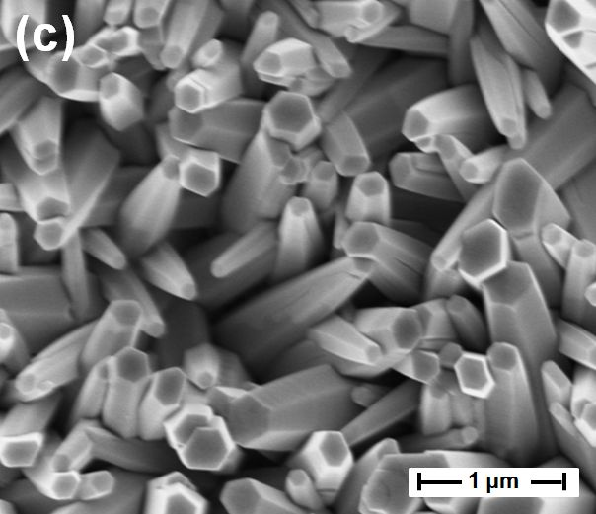
 | 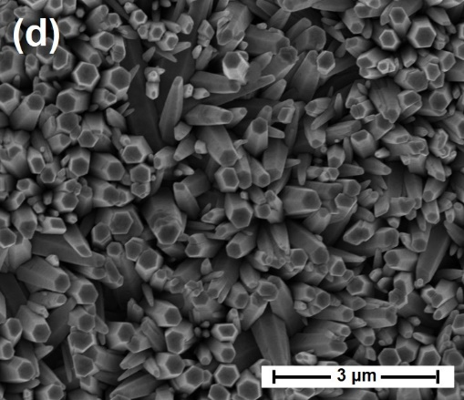 |  | 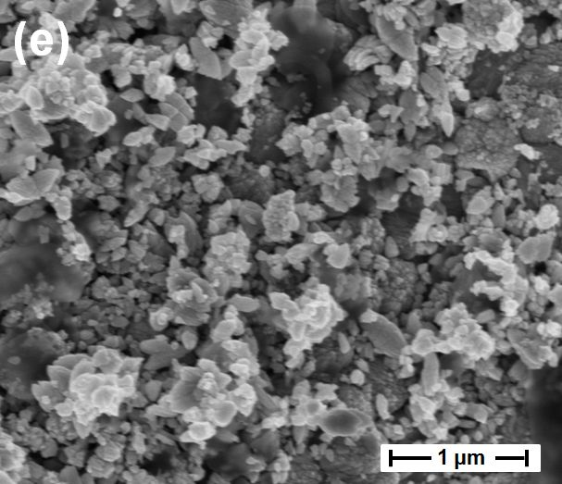
Fig. 2 SEM images of the as-grown ZnO NRs with different hydrothermal time of (a) 0.5h, (b) 1h, (c) 3h, (d) 5h, (e) 7h
Figure 5 shows the room temperature PL spectra of the ZnO NRs with different hydrothermal growth time. Generally speaking, a PL spectrum of ZnO normally contains a narrow UV emission peak (384 nm) and a weak broad green emission band. The UV emission peak corresponds to the near-band-edge emission and free exciton peak of ZnO [28]. On the other hand, the broad green emission band of the visible region is maximum at 610 nm and can be attributed to the intrinsic defects or oxygen vacancies in the ZnO, such as the single and double ionized oxygen vacancies [28, 29]. The higher the intensity ratio between the UV emission and green emission band indicates the better crystallinity of ZnO. Similar to the Raman results, the crystallinity of the as-grown ZnO was significantly improved with respect to the increased growth time from 0.5 to 5h. The ZnO NRs with 5h growth time exhibit the highest intensity ratio between UV and green emission band which again denotes the highest obtained crystallinity.
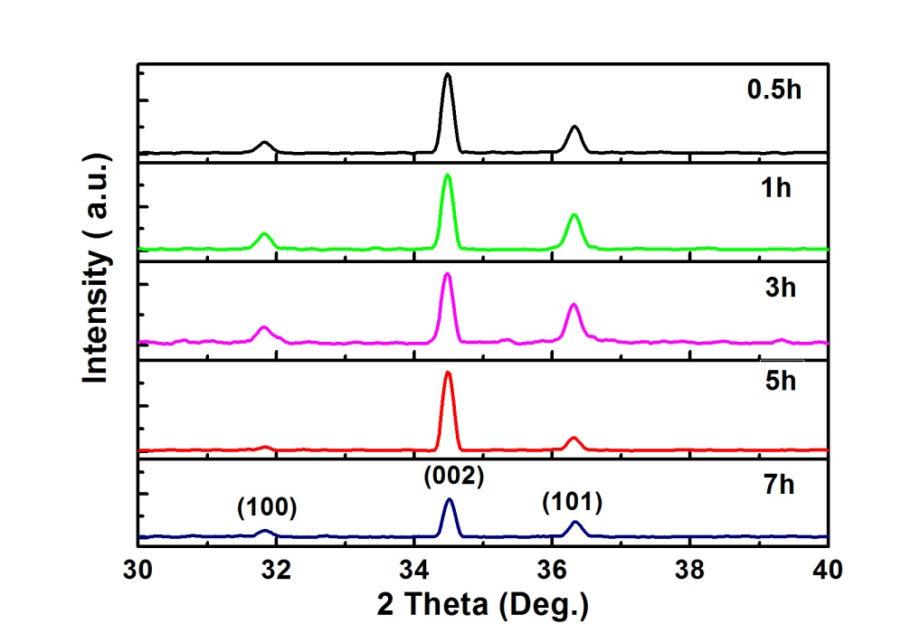
Fig. 3 X-ray patterns of the as-grown ZnO NRs with different hydrothermal time
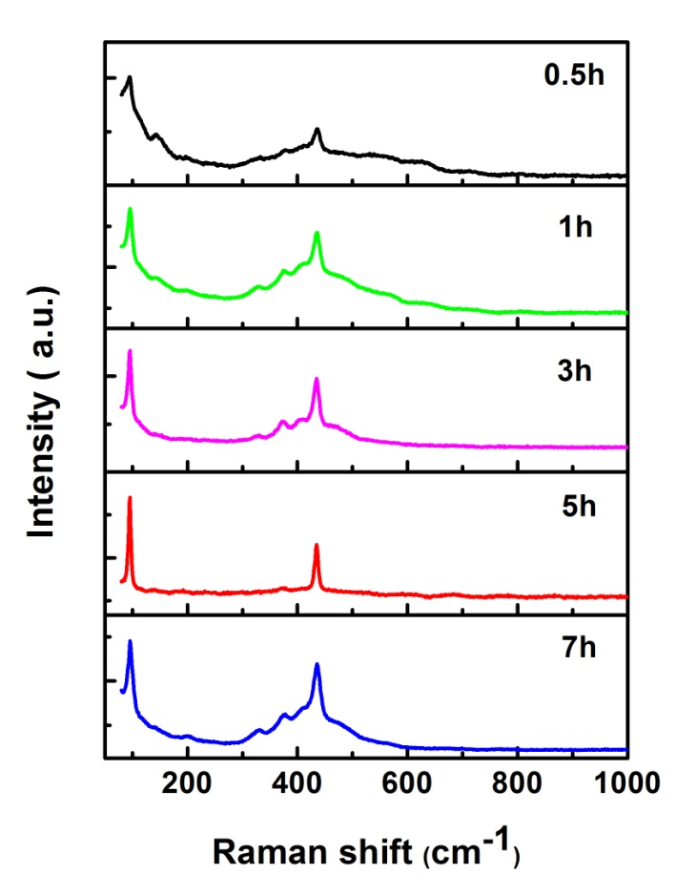
Fig. 4 Raman scattering spectra of the as-grown ZnO NRs with different hydrothermal time
Fig. 5 Photoluminescent spectra of the as-grown ZnO NRs with different hydrothermal time

4. Conclusion
In this study, high-crystallinity, high-density and well-aligned ZnO NRs grown on low-cost effective PCB substrates were obtained by using a seedless hydrothermal method together with galvanic effect under saturated nutrition solution. The structural, morphological and optical properties of ZnO NRs synthesized by varying the hydrothermal hydrothermal time have been investigated. The SEM, XRay, Raman and PL spectra have confirmed the improvements in both vertical alignment and crystallinity during duration growth period of ZnO NRs from 0.5 to 7 h. The best results were obtained with 5h hydrothermal time. We believe that the possibility of growing ZnO NRs on cost-effective PCB substrate will create a good impact on the production of low-cost electronic and optoelectronic devices.
Acknowledgements
This work was supported by the National Foundation for Science and Technology Development (NAFOSTED) of Vietnam through Grant No. 103.03-2015.27.
References:
1. Ahsanulhaq Q, Kim J-H, Hahn Y-B (2007) Controlled selective growth of ZnO nanorod arrays and their field emission properties. Nanotechnology 18:485307
2. Sun XW, Wang JX (2008) Fast Switching Electrochromic Display Using a Viologen-Modified ZnO Nanowire Array Electrode. Nano Lett 8:1884–1889 . doi: 10.1021/nl0804856
3. Soci C, Zhang A, Xiang B, et al (2007) ZnO Nanowire UV Photodetectors with High Internal Gain. Nano Lett 7:1003–1009 . doi: 10.1021/nl070111x
4. Low SS, Tan MTT, Loh H-S, et al (2016) Facile hydrothermal growth graphene/ZnO nanocomposite for development of enhanced biosensor. Anal Chim Acta 903:131–141 . doi: http://dx.doi.org/10.1016/j.aca.2015.11.006
5. Anta JA, Guillén E, Tena-Zaera R (2012) ZnO-Based Dye-Sensitized Solar Cells. J Phys Chem C 116:11413–11425 . doi: 10.1021/jp3010025
6. Yi F, Liao Q, Yan X, et al (2014) Simple fabrication of a ZnO nanorod array UV detector with a high performance. Phys E Low-dimensional Syst Nanostructures 61:180–184 . doi: https://doi.org/10.1016/j.physe.2014.03.025
7. (2012) ZnO Nanorod Arrays Applied as Broad-Spectrum Sensors for Detecting Various Volatile Organic Solvents. Nanosci Nanotechnol Lett 4:
8. (龙浩) HL, (李颂战) SL, (莫小明) XM, et al (2013) Electroluminescence from ZnO-nanorod-based double heterostructured light-emitting diodes. Appl Phys Lett 103:123504 . doi: 10.1063/1.4821346
9. Huang L, Wang X, Yin F, et al (2016) ZnO nanorods grown directly on copper foil substrate as a binder-free anode for high performance lithium-ion batteries. Int J Electrochem Sci 11:8439–8446 . doi: 10.20964/2016.10.60
10. Mai HH, Pham VT, Nguyen VT, et al (2017) Non-enzymatic Fluorescent Biosensor for Glucose Sensing Based on ZnO Nanorods. J Electron Mater 46:3714–3719 . doi: 10.1007/s11664-017-5300-8
11. Nandi R, Appani SK, Major SS (2017) High resolution X-ray diffraction studies of epitaxial ZnO nanorods grown by reactive sputtering. J Appl Phys 121:215306 . doi: 10.1063/1.4984935
12. Rezabeigy S, Behboudnia M, Nobari N (2015) Growth of ZnO Nanorods on Glass Substrate by Chemical Bath Deposition. Procedia Mater Sci 11:364–369 . doi: https://doi.org/10.1016/j.mspro.2015.11.130
13. Hu M, Zhang X, Meng X (2009) Photoluminescence of ZnO nanorods grown by hydrothermal method on Si substrate. Wuhan Univ J Nat Sci 14:415–418 . doi: 10.1007/s11859-009-0509-x
14. Ning J, Xu S, Wang R, et al (2009) Correlated Band-Edge Emissions of ZnO Nanorods and GaN Underlying Substrate. Jpn J Appl Phys 48:21102
15. Chew ZJ, Li L (2013) A discrete memristor made of ZnO nanowires synthesized on printed circuit board. Mater Lett 91:298–300 . doi: 10.1016/j.matlet.2012.10.011
16. Chew ZJ, Li L (2012) Localised zinc oxide nanowires growth on printed circuit board by in-situ joule heating. Mater Lett 76:226–228 . doi: 10.1016/j.matlet.2012.02.111
17. Compagnone D, Baldini F, Di Natale C, et al (2015) Sensors: Proceedings of the Second National Conference on Sensors, Rome 19–21 February, 2014. Lect Notes Electr Eng 319:271–275 . doi: 10.1007/978-3-319-09617-9
18. Errico V, Arrabito G, Plant SR, et al (2015) Chromium inhibition and size-selected Au nanocluster catalysis for the solution growth of low-density ZnO nanowires. Sci Rep 5:12336 . doi: 10.1038/srep12336
19. Van Thanh P, Mai HH, Tuyen NV, et al (2017) Zinc Oxide Nanorods Grown on Printed Circuit Board for Extended-Gate Field-Effect Transistor pH Sensor. J Electron Mater 46:1–6 . doi: 10.1007/s11664-017-5369-0
20. Yang Z, Wang M, Shukla S, et al (2015) Developing Seedless Growth of ZnO Micro/Nanowire Arrays towards ZnO/FeS2/CuI P-I-N Photodiode Application. Sci Rep 5:11377 . doi: 10.1038/srep11377
21. Hung SC, Lin CM, Cheng NJ, Li YM (2016) Effect of Solution on One-Step Hydrothermal Growth of ZnO Nanorod Arrays and its Application to Ultraviolet Photodetectors. J Nano Res 40:46–57 . doi: 10.4028/www.scientific.net/JNanoR.40.46
22. Wang RC, Lin HY, Chen SJ, et al (2009) Boundary layer-assisted chemical bath deposition of well-aligned ZnO rods on Si by a one-step method. Appl Phys A Mater Sci Process 96:775–781 . doi: 10.1007/s00339-009-5271-6
23. Jang J-M, Kim J-Y, Jung W-G (2008) Synthesis of ZnO nanorods on GaN epitaxial layer and Si (100) substrate using a simple hydrothermal process. Thin Solid Films 516:8524–8529 . doi: 10.1016/j.tsf.2008.05.017
24. Sun Y, Riley DJ, Ashfbld MNR (2006) Mechanism of ZnO nanotube growth by hydrothermal methods on ZnO film-coated Si substrates. J Phys Chem B 110:15186–15192 . doi: 10.1021/jp062299z
25. Cheng H-M, Hsu, Tseng Y-K, et al (2005) Raman Scattering and Efficient UV Photoluminescence from Well-Aligned ZnO Nanowires Epitaxially Grown on GaN Buffer Layer. J Phys Chem B 109:8749–8754 . doi: 10.1021/jp0442908
26. Nayak J, Sahu SN, Kasuya J, Nozaki S (2008) Effect of substrate on the structure and optical properties of ZnO nanorods. J Phys D Appl Phys 41:115303
27. Nandi R, Joshi P, Singh D, et al (2014) Structural and optical properties of ZnO nanorods grown chemically on sputtered GaN buffer layers. Thin Solid Films 555:122–125 . doi: http://dx.doi.org/10.1016/j.tsf.2013.10.152
28. Zhang R, Yin P-G, Wang N, Guo L (2009) Photoluminescence and Raman scattering of ZnO nanorods. Solid State Sci 11:865–869 . doi: http://dx.doi.org/10.1016/j.solidstatesciences.2008.10.016
29. Nayak J, Sahu SN, Kasuya J, Nozaki S (2008) Effect of substrate on the structure and optical properties of ZnO nanorods. J Phys D Appl Phys 41:115303

