ASSESSMENT OF SUSTAINABLE DEVELOPMENT INDEX FOR THANH HOA PROVINCE DURING PERIOD FROM 2010 - 2014
Lam Tuan Manh¹, Nguyen Tai Tue¹, Tran Dang Quy¹, Ta Thi Hoai¹, Mai Trong Nhuan¹, Nguyen Duc Hoai¹
¹VNU University of Science, 334 Nguyen Trai Street, Thanh Xuan, Hanoi, Vietnam

Abstract: Thanh Hoa is one of the fastest growing provinces in Vietnam and typical for strategic position in economy, society, national security and foreign affairs of the country. However, the socio-economic development is facing a range of challenges such as population growth, social inequality, environmental pollution and natural resource over-exploitation. In this paper, the establishment of sustainable development indicators (SIs) was implemented in order to measure the sustainability of Thanh Hoa province based on the analysis of the socio-economic characteristics and the sustainable development index (SDI). The proposed indicators framework consisted of five dimensions (economy, society, environment, infrastructure and governance), containing 33 indicators that potentially provided quantified methods for decision makers to examine better sustainability model and strategies in the current global and climate change scenario. Results showed that during the period from 2010 to 2014, Thanh Hoa province has generally developed to follow positive direction with continuously increasing the SDI scores over the years. In particular, the SDI in year 2014 (0.484) was much higher than that in comparison to year 2010 (0.136). Our results showed that these indicators can be potentially applied to other provinces of Vietnam to examine the sustainable development of whole country.
Key words: sustainable development, a set of indicators, index, climate change, Thanh Hoa province

1. INTRODUCTION
Sustainable development is global and national goals, aiming to improve three important pillars of economy, environment and society for present and future generations. Our actions today must provide immediate needs without diminishing the assets, resources, availability and demands of later generations [1]. All the countries on globe are on agreement of sustainable development goals. Sustainable development has been addressed in different research areas [2-6], in which assessment of sustainable development index (SDI) will provide vital information for building a better and sustainable society [3]. Since the first appearance in the year of 1980, sustainable development goals need to be updated to reflect different development trends. Nowadays, sustainable development not only covers economic, social and environmental aspects, but also extends to other fields such as renovation and development of infrastructure [4, 7], urban governance, global climate change [4].
Sustainable development indicators (SIs) play a very important role for assessing, monitoring the status of local, regional, national and global scale [4, 7, 8]. A sound SIs will provide a method to propose better strategies and to allocate resource utilization [9].
Recognizing the need for monitoring the sustainable development of Vietnam, the Prime Minister issued a series of legal documents to guide and to implement Vietnam's sustainable development strategies and goals, consisting of Decision No. 153/2004/QD-TTg, No. 432/QD-TTg [10], No. 1602/QD-TTg, No. 160/QD-TTg and Decision No. 2157/QD-TTg [11]. In which, Decision No. 2157/QD-TTg provided a system of 28 general statistics indicators, covering economic, social, environmental pillars and 15 specific indicators for different regions. In practice, several indicators were very difficult to collect the statistical data [2]. Later, Tran Van Y et al. [8] proposed 77 indicators at regional, 70 indicators at provincial and 49 indicator at district level for Central Highland. Le Trinh Hai [12, 13] used Delphi method to propose a set of SDI for Quang Tri province (39 indicators) and Thai Binh (39 indicators). These results contributed to enlarge the application of sustainable development assessment, but some limitations could be shown as following: (1) the SDIs are very large and difficult to apply for other regions, (2) a few applications to monitor the sustainable development in other areas [8] and (3) indicators are not updated with the latest sustainable development goals of United Nations.
Therefore, the objectives of this paper are to develop a set SIs, methods of data processing and assessment SDI and to apply these SIs for assessing the sustainable development of Thanh Hoa province during period from 2010 to 2014.

2. STUDY AREA
Thanh Hoa province is located in the northern of Central Vietnam, 150 km south from Hanoi Capital, ranked the 5th of land area [14] with 24 districts, two towns, one city (Figure 1) and one economic zone close to Nghi Son port, which is the regional economic zone of North Central Vietnam. In 2015, Thanh Hoa’s population was recorded at 3,514,200 and making it the 3rd populous area in Vietnam [15]. With these typical characteristics, Thanh Hoa has great physical diversity in terrains and ecosystems as follows: hilly midland and mountainous in western districts, plain and coastal area, forest and sea. These natural conditions provide great opportunities for developing variety of mixed economic types with industry, mining, agriculture, forestry and agro-forestry production, fishery, tourism, border economy, hydroelectric power, and services [14]. In addition, the National Highway 1A, commonly referred as QL1A that runs through Thanh Hoa and this longest and busiest highway connects north to south provinces of country. With above mentioned advantages, Thanh Hoa has much potential and favorable geographical location for socio-economic development in the present as well as in the future. Local economic growth reached 8.39% in 2015 based on the new measure method of GRDP [16].
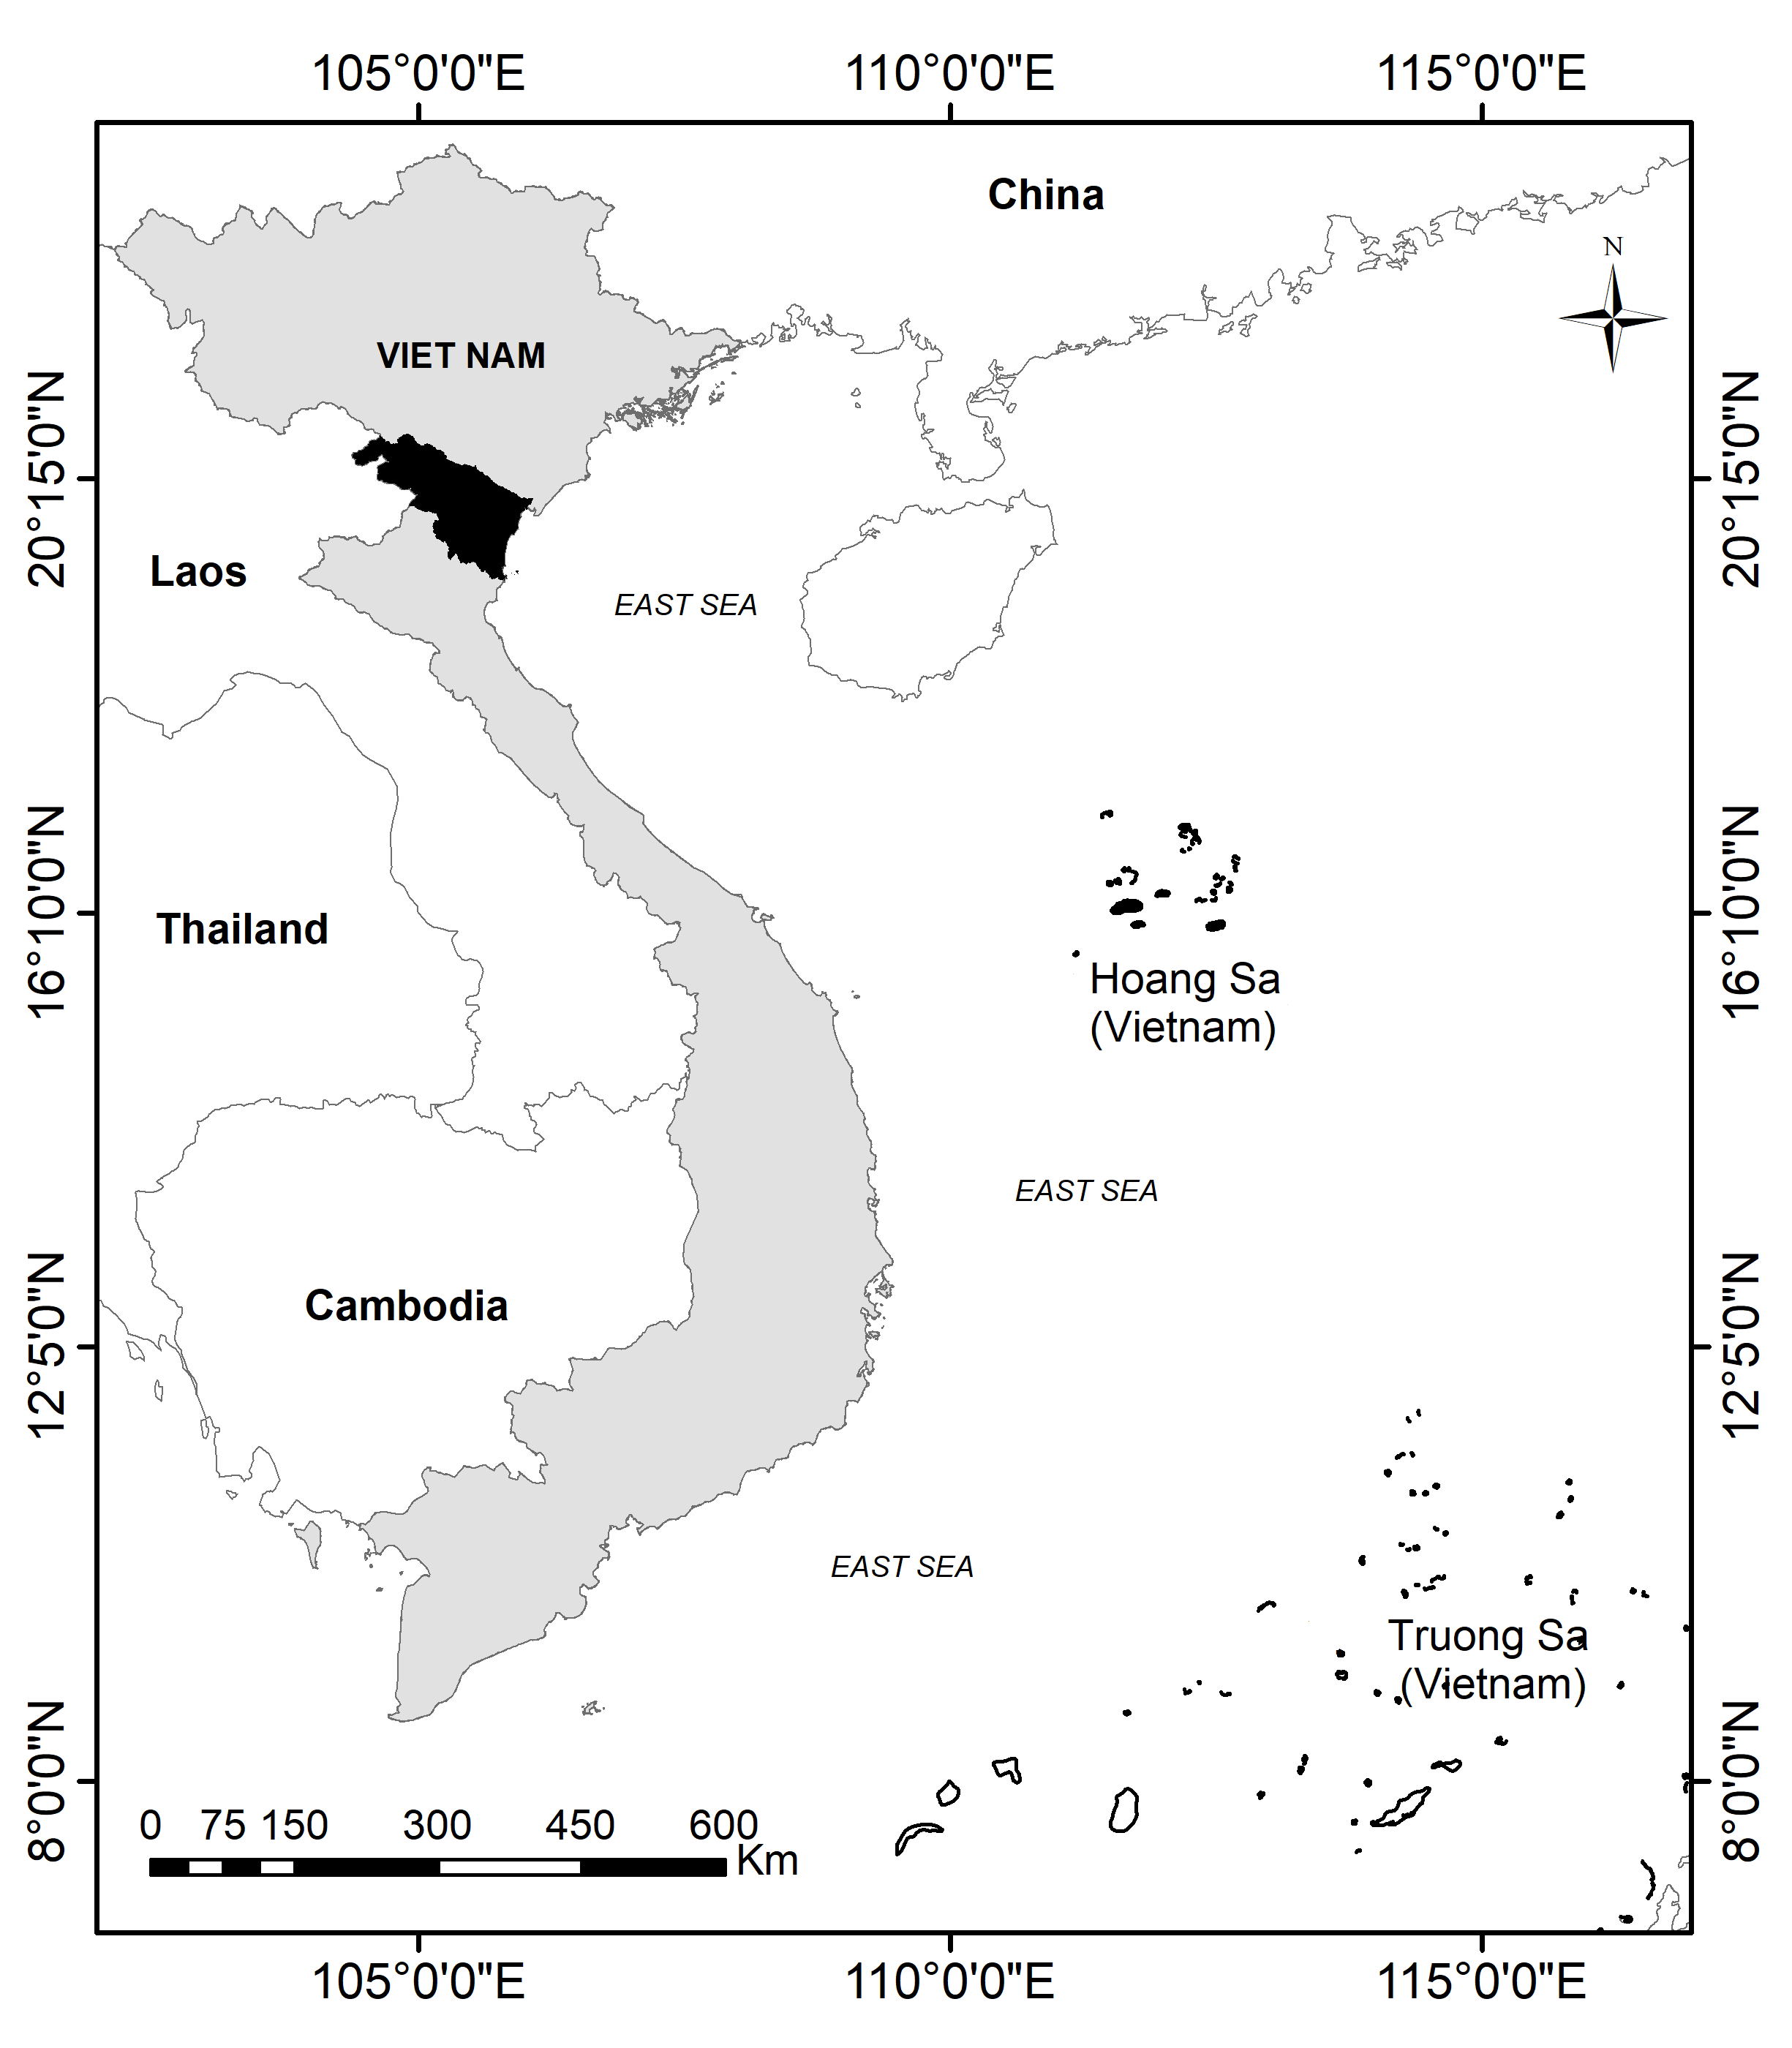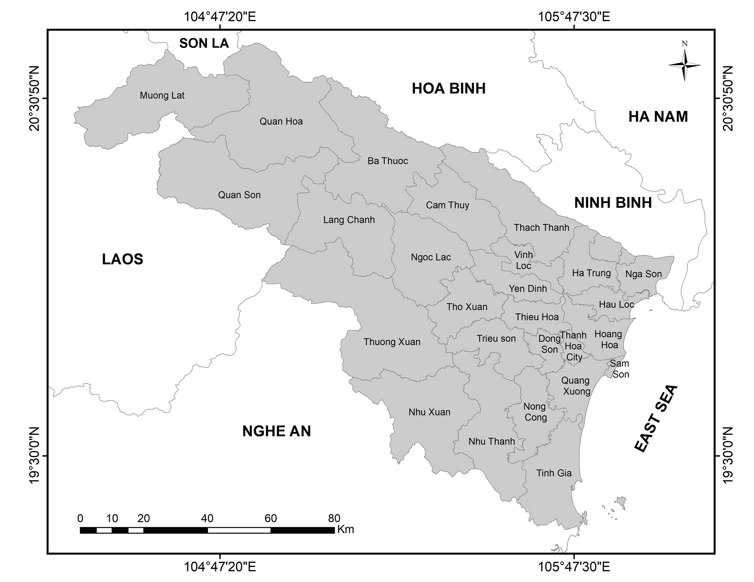
Figure 1. Geographical location and administrative map of Thanh Hoa province
On other side, the province is also facing with over population and manage waste. Solid waste was estimated to be 1,491.1 tons/day and 539,595 tons/day for rural and urban areas, respectively [17]. Currently, the waste collection rate in urban areas has reached 78.35% and a lower rate 55.6% in the rural and mountainous areas, uncollected waste lies a scattered on the roadside or these wastes are channeled in to rivers and lakes through canals, streams or sewers.
Climate change is also one of greatest challenges affects a variety factors to sustainable development of Thanh Hoa province. In the past 50 years, the annual rainfall in Thanh Hoa tended to decrease, causing water scarcity and drought. However, here is a favorite destination of typhoons, 18 tropical storms and depressions entered and 27 tropical storms and depression affected Thanh Hoa province from 1980 - 2010. Other natural disasters that occur frequently like flash flood, landslide death toll 12 people, 47 houses washed away (1999-2009).
Therefore, analysis and assesses of the sustainable development of Thanh Hoa province will provide crucial tools to improve the economics, social and environmental sustainability. The framework will also provide recommendations on how to reverse “negative” ones or to sustain “positive” gains from a sustainable development perspective.

3. SUSTAINABLE DEVELOPMENT INDICATORS AND RESEARCH METHODS

3.1. Establishment of indicator set for sustainable development assessment
The SDI is developed and identified five steps as follows (Figure 2). Sustainable development can be achieved when the fundamental aspects of life are continuous improved and enhanced. Apart from the basic elements surrounding people such as economics, society, environment, aspects of infrastructure and urban governance play a very important role. Infrastructure is essential for increasing economic progress and reducing poverty and also have major implications for environmental sustainability [18]. So the sustainable development indicators have been built and developed to assess the level of sustainable socio-economic development but ensure environmental sustainability and sustainable management. Therefore, the five basic selected pillars that are inherited the contents and dimensions of the case studies around the world, such as the US [1], UK [19], Hong Kong [3], Wales [20], Malaysia [21, 22] and complied with the content of sustainable development of Vietnam [10, 11] in general, and Thanh Hoa province in particular. The five basic selected pillars were economy, social, environmental, infrastructure and urban governance, together with their respective sub-dimension and indicators (Table 1). In this paper, the 33 proposed indicators were chosen to ensure three major criteria: easy to understand, compilation for Vietnam and Thanh Hoa province, and data availability [24, 25].
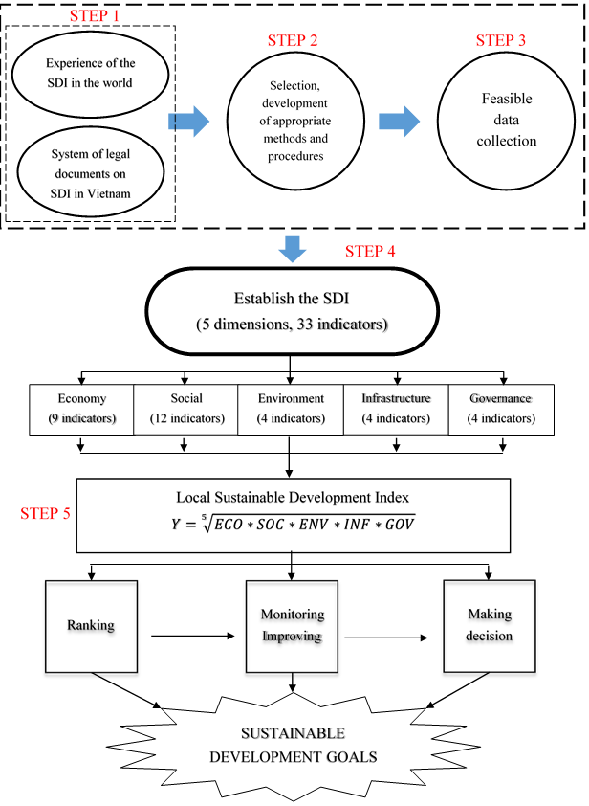
Figure 2. A framework to assess the SDI
Table 1. Sustainable development indicators for Thanh Hoa province
Dimension | Sub-Dimension | Indicators | Sources | Scoring methods
Economy | Economy growth | 1. GRDP growth rate | [15, 25] | Eq.1
 |  | 2. Monthly average income per capital | [15, 25] | Eq.1
 | Sustainable finance | 3. ICOR coefficient | [15, 25] | Eq.2
 |  | 4. The rate of state budget revenue over budget expenditure in the province | [15, 25] | Eq.1
 | Labor | 5. Unemployment rate | [15, 25] | Eq.2
 |  | 6. Percentage of trained employed population aged 15 and over | [15, 25] | Eq.1
 |  | 7. Labor productivity | [15, 25] | Eq.1
 | Export - Import | 8. Export growth rate | [15, 25] | Eq.1
 |  | 9. Balance of Trade (BOT) | [15, 25] | Eq.1
Social | Population | 10. Population growth rate | [15, 25] | Eq.2
 |  | 11. Population density | [26] | Eq.2
 | Poverty & Inequalities in income | 12. Poverty rate | [15, 25] | Eq.2
 |  | 13. GINI coefficient | [15, 25] | Eq.2
 | Health care | 14. Doctor per 10000 inhabitants | [15, 25] | Eq.1
 |  | 15. Rate of under-one-year children fully vaccinated | [15, 25] | Eq.1
 |  | 16. Under-five-malnutrition rate (%) | [15, 25] | Eq.2
 | Education | 17. Percentage of literate population aged 15 and over | [15, 25] | Eq.1
 |  | 18. Enrolment rate at right age | [15, 25] | Eq.1
 |  | 19. Percentage of graduates of upper secondary | [15, 25] | Eq.1
 |  | 20. Number of students per 10000 inhabitants | [15, 25] | Eq.1
 | Culture - Sport | 21. Percentage of local budget expenditures for cultural - sports activities | [15, 25] | Eq.1
Environment | Water quality/quantity | 22. Rate of households using hygienic water | [15, 25] | Eq.1
 | Waste | 23. The total amount of solid waste generated daily living | [17] | Eq.2
 | Natural resource | 24. Forest coverage rate | [17] | Eq.1
 |  | 25. Percentage of land protected and maintained biodiversity | [15, 25] | Eq.2
Infrastructure | Health services | 26. Number of beds per 10000 inhabitants | [15, 25] | Eq.1
 | Electricity | 27. The percentage of households using electricity | [26] | Eq.1
 | Information and communication technology | 28. Number of internet subscribers per 100 inhabitants | [15, 25] | Eq.1
 |  | 29. Number of telephone subscribers per 100 inhabitants | [15, 25] | Eq.1
Governance | Urban Security | 30. Number of deaths by traffic accidents per 100.000 inhabitants | [15, 25] | Eq.2
 | Environment management | 31. Number of employees in acting enterprises in waste collection, treatment and disposal activities | [15, 25] | Eq.1
 |  | 32. Number of acting enterprises in waste collection, treatment and disposal activities | [15, 25] | Eq.1
 | Quality of economic and business environment governance | 33. Provincial Competitiveness Index (PCI) | [27] | Eq.1

3.2. Scoring Methods
To compute each dimension index, there may be raw SDIs present in different characteristics, formats and units, thus it is necessary to convert them to a unique identifier type for comparison. Many methods are applying to standardize, such as statically standardization, empirical standardization, axiological standardization and mathematical standardization [28]. In this paper, the real statistical value of the indicators was normalized to the range value between 0-1 [29]. To perform this work, the expert evaluation, and Min/Max calculation were applied.
Sustainable development indicators contain two types of indicators [30], consisting of the reverse indicators (indicator values affect as the same with the integrated index), and inverse indicators (indicator values inversely affect to the integrated index). Each indicator type applied in different equations as follows:
- For reverse indicators:
$I_{rev}=\frac{X - Xmin}{max X - minX}$ (Eq.1)
- For inverse indicators:
$I_{inv}=\frac{Xmax - X}{maxX - minX}$ (Eq.2)
For Eq. (1) and Eq. (2), X is a value of indicator X; maxX and minX denotes for the maximum and minimum scaled values of indicator X, respectively.
Sustainable development indicators of each dimension and the SDI of Thanh Hoa province are calculated using the unweighted average method. This method is quite suitable for sustainable development assessment because it promotes the uniformity of values between dimensions [31], creates balanced and harmonious development as the sustainable development goals[1]. The results showed the comprehensive picture in socio-economic development of Thanh Hoa province.
Five dimensions of economic, social, environmental, infrastructure and government capacity were calculated following Eq. 3:
$I_{Dimension}=\sqrt[n]{\prod_{i=1}^{n}{I_{i}}}$ (Eq.3)
Where $I_{Dimension}$ is $I_{ECO}$ (Index of economic dimension), $I_{SOC}$ (Index of social dimension), $I_{ENV}$ (Index of environment dimension), $I_{INF}$ (Index of infrastructure dimension), $I_{GOV}$ (Index of governance dimension) and i is corresponding indicators of each dimension.
The SDI is calculated by the following equation:
$Y=\sqrt[5]{ECO*SOC*ENV*INF*GOV}$ (Eq.4)
The aggregate SDI (Y) is closer to 1, meaning the development more sustainable and vice versa [2, 8, 24, 31].

3.3. Data collection
According to the proposed SIs (see Table 1) and the data available, the SDI was evaluated for Thanh Hoa province during the period 2010 - 2014. The socio-economic and environmental data were collected from various sources, consisting of Thanh Hoa Statistical Yearbook during period 2010 - 2014 [15], data from the statistics office of Thanh Hoa province [24], from the official website of the province (http://thanhhoa.gov.vn) [14], from the website of the General Statistics Office http://gso.gov.vn [26], and official documents published by functional agencies such as the Report on Socio-Economic Development of the locality [16] period 2010 - 2015, the State of the environment Report of Thanh Hoa province from 2011- 2015 [17], Political Report period 2010 - 2015 by the Thanh Hoa People’s Committee [32].
Data analysis and calculate the dimension indices and the SDI in using Microsoft Excel, SPSS.

4. RESULTS AND DISCUSSION

4.1. Sustainable development dimensions index
The SDI has gradually increased in each year of period 2010 - 2014 due to the positive changes of the dimensions. However, the social index and the environmental index were relatively low (Table 2). Results showed that the aggregate sustainability index was highly dependent on the respective dimensions and indicators. The result of each sustainable development dimension of Thanh Hoa province during period from 2010 to 2014 is presented as follows:
For the economic dimension, results showed that the index of economics of Thanh Hoa province has continuously increased. This achievement reflected that labor productivity, GDP, import-export ratio and balance of trade had continuously increased over the years. The percentage of trained employees increased from 16.2% in 2010 to 18.9% in 2014, contributes significantly to the economic growth. However, the unemployment rate fluctuated around 2 - 2.14 percent that still has not improved [15].
The social dimension has unevenly variety and got low value (Table 2). For example, although Education has a good result with literacy rate aged 15 >94% and constantly increasing over the years, high school graduation rate is 99-100%, but Population, Health sub-dimensions has not achieved high score (Figure 3), especially the poverty rate in the province was 10% (in 2010 approximately 25%), the severity of under-five child malnutrition rate ranged from 18-23%, being high that directly degraded the sustainable development score of social dimension with (0.264 - 0.367, Table 2).
The environmental dimension has significantly increased in the period 2010 - 2014 with varied in a large range from 0.076 - 0.340, lower than other dimensions. The poorly score of environmental indicators showed that it is needed the efficient efforts for reduce negative environmental impacts by reducing waste water and improving water quality, waste pollution (not only treating waste), better energy efficiency and improving waste management of sub-urban and rural areas. Despite the proportion of households have access to improved water increased annually, but occupied only 16.26 - 20.30% [15].
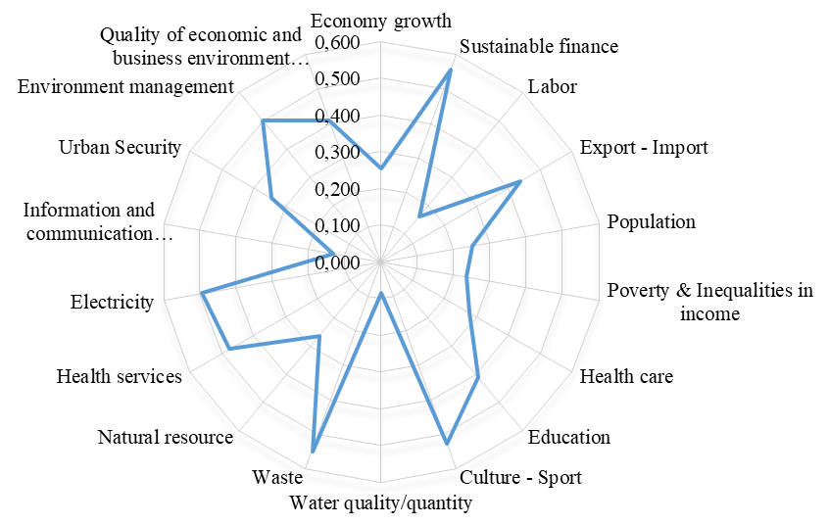
Figure 3. Results of the average sub-dimensions during the period 2010 – 2014
Results showed that 7/12 indicators of the social dimension and 3/4 indicators of the environmental dimension have not reached the average mean (0.5) and has an unstable tendency over recent years (Figure 4).
Infrastructure investment has been special emphasis, but has an infrastructure gap wider between city and countryside. All indicators in this dimension such as the percentage of households with electricity, number of hospital beds per 1,000 inhabitants, telephone subscribers keep rising and more people have cellphones through the years. The score of this dimension has increased continuously over the years and the highest score was up to 0.645 in 2014 in comparison to 0.11 in the year 2011 [27]. The provincial government makes efforts to continuously improve the PCI score (Provincial Competitiveness Index) with ranked ten (10/63). Moreover, urban public safety is frequently maintained and improve in better condition, improving solid waste management capacity in the field of garbage collection is constantly raising, making the governance dimension to have a significant improved over time (Table 2).
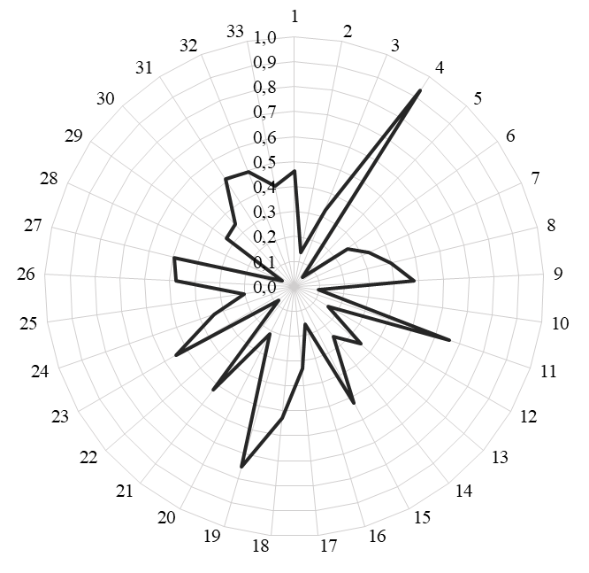
Figure 4. The average value of indicators during the period from 2010 - 2014

4.2. Sustainable development index of Thanh Hoa province during period from 2010 to 2014
With the positive changes from the dimensions index over the years, the SDI of Thanh Hoa province has improved considerably but still relatively low (increased from 0.136 in 2010 to 0.484 in 2014, Table 3). Results showed that hanged of the Thanh Hoa’s SDI period 2010 - 2014 is mainly caused by positive improvement of the economics (0.504), infrastructure (0.645) and governance (0.651) dimension.
Table 2. Importance trend from 2010 - 2014
 | 2010 | 2011 | 2012 | 2013 | 2014
Highest index | Sustainable finance (0.766) | Sustainable finance (0.759) | Environment management (0.702) | Export - Import (0.831) | Export - Import (0.955)
Lowest index | Economy growth (0.026) | Information and communication technology (0.084) | Information and communication technology (0.091) | Water quality/ quantity (0.129) | Water quality/ quantity (0.151)
From 2010 to 2014, some indicators such as: sustainable finance, environmental management, and import - export contributed significantly to the improvement of Thanh Hoa’s SDI (Table 2). On the other hand, a bunch of indicators have low scores cause of drop in the SDI: Information and communication technology (in 2011 and 2012) and especially the quality and quantity of clean water for the daily life (in 2013 and 2014).
Table 3. Results of Sustainable Development index in Thanh Hoa Province,
in the period 2010 - 2014
Dimension | Economy Index | Social Index | Environmental Index | Infrastructure Index | Governance Index | Sustainable Development Index
2010 | 0.107 | 0.264 | 0.076 | 0.112 | 0.193 | 0.136
2011 | 0.285 | 0.337 | 0.275 | 0.195 | 0.443 | 0.296
2012 | 0.308 | 0.329 | 0.304 | 0.228 | 0.446 | 0.316
2013 | 0.460 | 0.304 | 0.348 | 0.323 | 0.623 | 0.397
2014 | 0.504 | 0.367 | 0.340 | 0.645 | 0.651 | 0.484
The assessment and identification of the SDI of Thanh Hoa province using the SIs contributed to propose solutions, policies, raising the threshold of sustainable development of the province in the future years. In order to improve the SDI, Thanh Hoa province needs to revise its master plans and mid-range plan as well as design solutions for improving low score dimensions. Some suggests solutions can be applied to solve problems: priorities and strongly improve of the clean water supply system, encourage and raising number of people with access to information and communication technologies, especially in mountainous and remote areas, offer apprenticeships, short-training course or on-job-training for working-age, reduce unemployment rate, and promoting economic growth that achieved builds up competence and it is sustainable. Anyway, boosting growth is not the way to solve environmental problems.

5. CONCLUSIONS AND THE FUTURE RESEARCH
This paper presented in details the sustainable development indicators and methods of assessment of the SDI for Thanh Hoa province during the period of 2010 - 2014. The geometrical average method used to compute the sub-dimensions, dimensions and the SDI. Results shows the current situation of sustainable development in the locality, pointed out several indicators and sub-dimensions that need to specifically focus to increase the sustainable development of Thanh Hoa province. Generally, Thanh Hoa province is success in improving the the SDI over the years, yet the SDI still remained at the average level (approximately 0.5 in 2014).
For future research, the SIs should be considered to apply to other provinces of Vietnam for assess the SDI. After that, the provincial SDI should be compared to get the sustainable development scores for whole country. The results will contribute to develop the strategic orientation for sustainable development in Vietnam and its implementation.
Acknowledgement: The authors are grateful thanks to staff of VNU University of Science, Vietnam for their help and assistance with data collection and processing. This research was supported by the National Science and Technology Program for Sustainable Development of Vietnam’ Northwest Region (KHCN-TB.19C/13-18).
REFERENCE
- SDI GROUP, Sustainable Development in the United States: An Experimental Set of Indicators, Washington, DC, SDI Group (December), 1998.
- Thu, N.T.M., Statistical research on sustainable development in Vietnam, PhD thesis in Economics, 2013.
- Tso, G.K., K.K. Yau, and C. Yang, Sustainable development index in Hong Kong: Approach, method and findings, Social Indicators Research 101(1), p. 93-108 (2011).
- Sachs, J., G. Schmidt-Traub, C. Kroll, D. Durand-Delacre, and K. Teksoz, SDG Index and dashboards - A global report, New York: Bertelsmann Stiftung and Sustainable Development Solutions Network (SDSN), 2016.
- Adelle, C. and M. Pallemaerts, Sustainable Development Indicators - Overview of Relevant FP - Funded Research and Identification of Further Needs, Europen Comission, Brussels, 2009.
- Asian Development Bank, Developing Indicators and Monitoring Systems for Environmentally Livable Cities in the People’s Republic of China, 2014.
- United Nations, Global Sustainable Development Report 2016, Department of Economic and Social Affairs, New York, 2016.
- Y, T.V., N.D. Tri, L.T. Can, T.T. Chi, N.T. Chinh, N.X. Hau, N.V. Hieu, D.Q. Tuan, N.V. Thinh, N.T. Tuan, and J. Hennessy, Establishing a Sustainable Development Indicator Set Including Economic, Social and Environmental Fields in Tay Nguyen Provinces, Vietnam Journal of Earth Sciences. 36(3), p. 241-251 (2014).
- Sustainable Development Solutions Network - United Nation, Indicators and a monitoring framework for sustainable development goals: Launching a data revolution for the SDGs, Sustainable Development Solutions Network, 2015.
- Prime Ministry, Decision approving the Vietnam Sustainable Development Strategy 2011-2020, in No. 432/QĐ-TTg, 12/04/2012.
- Prime Ministry, Decision on promulgation of the set of indicators for monitoring and evaluation of local sustainable development in the period of 2013 - 2020, in No. 2157/QĐ-TTg, 11/11/2013.
- Hai, L.T., P.H. Hai, P.T.T. Ha, N.M. Ha, L.T. Dai, P.V. Hoa, N.C. Huan, and L.V. Cam, A system of sustainability indicators for the province of Thai Binh, Vietnam. Social Indicators Research. 116(3), p. 661-679 (2014).
- Hai, L.T., P.H. Hai, N.T. Khoa, and L. Hens, Indicators for Sustainable Development in the QuangTri Province, Vietnam, 2009.
- Thanh Hoa Official Portal. http://thanhhoa.gov.vn, Access on 10/27/2017.
- Thanh Hoa Statistical Office, Thanh Hoa Statistical Yearbook 2014. Statistical Publishing House, 2015.
- The Thanh Hoa People’s Committee, The Report of Socio-Economic Development of Thanh Hoa Province 2014, 2015.
- Department of Natural Resources and Environment of Thanh Hoa Province, The Report on the current state of the environment of Thanh Hoa province from 2011 to 2015, 2015.
- Marianne F., Mike T., Daniel B.z and Stefan C., World Bank, Washington DC, Infrastructure and Sustainable Development, Paper prepared for Korea-World Bank Conference on Post-Crisis Economic Development, Busan, June 4 2010.
- Department For Environment Food & Rural Affairs - UK, Sustainable Development Indicators, 2013.
- Swain, K., Sustainable development indicators, 2015.
- Saadatian, O., C. Haw, S. Mat, K. Sopian, M. Dalman, and E. Salleh, Sustainable development in Malaysia-planning and initiatives, In WSEAS Conference, 2011.
- Hasan, M.N. and A.H. Adnan, Sustainable Development Indicator Initiatives in Malaysia-Novel Approaches and Viable Frameworks, Institue for Environment and Development (LESTARI), Universiti Kebangsaan Malaysia, 2004.
- Nhuan, M.T., N.T.H. Hue, N.T. Tue, and T.M. Lieu, Assessing the Adaptive Capacity of Coastal Urban Households to Climate Change (Case Study in Liên Chiểu District, Ðà Nẵng City, Vietnam), VNU Journal of Science: Earth and Environmental Sciences, 31(2) (2015).
- Nhuan, M.T., N.T. Tue, N.T.H. Hue, T.D. Quy, and T.M. Lieu, An indicator-based approach to quantifying the adaptive capacity of urban households: the case of Da Nang city, Central Vietnam, Urban Climate 15, p. 60-69 (2016).
- Thanh Hoa Statistics Department, http://ctk.thanhhoa.gov.vn, Access on 10/27/2017.
- General Statistics Office. http://gso.gov.vn, Access on 10/27/2017.
- VCCI, U., Provincial competitiveness index in 2015, 2016.
- Boulanger, P. M., Sustainable development indicators: A scientific challenge, a democratic issue, SAPI EN. S. Surveys and Perspectives Integrating Environment and Society (1.1), 2008.
- Parris, T.M. and R.W. Kates, Characterizing and measuring sustainable development, Annual Review of Environment and Resources, 28(1), p. 559-586 (2003).
- Bravo, G., The Human Sustainable Development Index: New Calculations and A First Critical Analysis, Ecological Indicators 37, p. 145-150 (2014).
- Tri, N.D., T.V. Y, T.Q. Hai, N.T. Tuan, and H.A. Le, Assessment of Sustainable Development Level of Gia Lai Province for the 2008-2012 Period, VNU Journal of Science: Earth and Environmental Sciences 32(1S), p. 407 - 412 (2016).
- The Thanh Hoa People’s Committee, Political report of Thanh Hoa Province in period 2010 -2015, 2015.

ĐÁNH GIÁ CHỈ SỐ PHÁT TRIỂN BỀN VỮNG TỈNH THANH HÓA

GIAI ĐOẠN 2010 - 2014
Lâm Tuấn Mạnh¹, Nguyễn Tài Tuệ¹, Trần Đăng Quy¹, Tạ Thị Hoài¹, Mai Trọng Nhuận¹, Nguyễn Đức Hoài¹
¹Trường Đại học Khoa học Tự nhiên, Đại học Quốc gia Hà Nội
334 Nguyen Trai Street, Thanh Xuan, Hanoi, Vietnam
Tóm tắt: Thanh Hóa là một trong những tỉnh có tốc độ phát triển nhanh ở Việt Nam, đặc trưng cho vị trí chiến lược về kinh tế, xã hội, an ninh quốc phòng của cả nước. Tuy nhiên, sự phát triển kinh tế - xã hội đang phải đối mặt với những thách thức như sự gia tăng dân số, bất bình đẳng xã hội, ô nhiễm môi trường và sự khai thác quá mức nguồn tài nguyên thiên nhiên. Bài báo này thực hiện nghiên cứu xây dựng bộ chỉ tiêu và đo lường hiện trạng phát triển bền vững tỉnh Thanh Hóa dựa trên việc phân tích những đặc điểm điều kiện tự nhiên, kinh tế xã hội của tỉnh. Bộ chỉ tiêu đề xuất gồm 5 khía cạnh (kinh tế, xã hội, môi trường, cơ sở hạ tầng và quản trị), bao gồm 33 chỉ tiêu có khả năng cung cấp phương pháp định lượng cho chính quyền ra quyết định để xem xét mô hình, định hướng chiến lược phát triển bền vững trong tương lai, đặc biệt trong bối cảnh biến đổi khí hậu toàn cầu hiện nay. Kết quả cho thấy, trong giai đoạn 2010 - 2014, tỉnh Thanh Hóa phát triển theo xu hướng tích cực, chỉ số PTBV liên tục tăng qua các năm, đặc biệt năm 2014 (0,484) cao hơn nhiều so với chỉ số PTBV năm 2010 (0,136). Bộ chỉ tiêu được nghiên cứu đề xuất hoàn toàn có thể được áp dụng cho các tỉnh thành khác của Việt Nam để đo lường hiện trạng phát triển bền vững của cả nước.
Từ khoá: phát triển bền vững, bộ chỉ tiêu, chỉ số, biến đổi khí hậu, tỉnh Thanh Hóa.

Corresponding author: Mobi: +84 966062416 Email: manhlamtuan@vnu.edu.vn

