Natural radioactivity and external dose assessment of surface soils in Bolikhamxay province, Laos
Somsavath Leuangtakoun^{1,2}∗, Bui Van Loat¹, Vu Thi Kim Duyen³, Khong Nam Khang⁴.
¹Department of Nuclear Physics, Faculty of Physics,VNU University of Science,
334 Nguyen Trai,Hanoi,Vietnam
²National University of Laos,P.O.Box: 7322 ,Dongdok Vientiane,Laos
³Centre for Env.Trea. Tech., Ministry of Defence, 282 Lac Long Quan, Hanoi, Vietnam
⁴Military Institute of Medical Radiology and Oncology.

Abstract: We have determined activity concentrations in 33 soil samples collected from Bolikhamxay Province, Laos. The activity concentrations of the natural radionuclides ²²⁶Ra,²³²Th and ⁴⁰K in soil samples were measured by a gamma spectrometer with a HPGe detector. The average activity concentrations of the natural radionuclides ²²⁶Ra, ²³²Th and ⁴⁰K are 43.8 ± 5.6, 57.0 ± 7.3 and 426.4 ± 23.1 Bq.kg⁻¹, respectively. The average activity concentrations of ²²⁶Ra and ²³²Th in this work are higher than those of the world average values. Meanwhile, the activity concentration of ⁴⁰ K is almost the same of the world average value. The estimated average outdoor annual effective dose (E) and radium equivalent actitvity (Ra_{eq}) are 0.17 ± 0.02 mSv.yr⁻¹ and 154.8 ± 16.1 Bq.kg⁻¹, respectively.
Keywords: Gamma spectrometry, Activity concentration, Radium Equivalent Activity, Absorbed gamma dose rate, Annual effective dose rate, Minimum Detection Limit.
1. Introduction
Natural radioactivity is widespread in the earth’s environment, it exists in the soil, plants, water, and airs. The gamma radiation from natural radionuclides and cosmic rays constitute the external exposure. Natural radionuclides in the soil generate a significant component of the background radiation exposure to the population [1,2]. Radionuclides in soils, belonging to the ²²⁶Ra and ²³²Th series, as well as radioisotope of the potassium (⁴⁰K), are the major contributors of outdoor terrestrial natural radiation [3]. Natural radioactivity depends primarily on the geological and geographical conditions, and appears at the different level in the soils of each region in the world (UNSCEAR,2000) [1]. Our present study aimed at the determining of the natural radionuclides levels, evaluating radiation hazard indices and the effective dose to the public from soil samples in Bolikhamxay Provine,Laos.
2. Materials and Methods
2.1. Study Area
Bolikhamxayis a province of Laos, located in the middle of the country on latitude 18.43${63}^{°}N$ and longitude $104.47{23}^{°}E$ as shown in Figure 1. The altitude ranges from 140- 1,588 metres an area of 15,977 square kilometers. The population of 190.000, rich of culture and nature resource with 3 national protected areas: PhouKhaoKhouay, NamKaDing and a part of Theun-Nakai. 'Pakxan' the capital of Bolikhamxay lies some 150km by South 13 Road from Vientiane.
Preparation and processing of soil samples

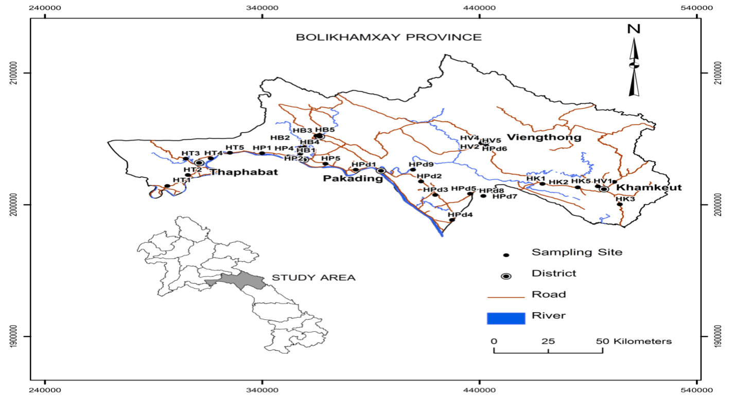
Figure.1. Sampling location in Bolikhamxay Province, Laos
2.2. Preparation and processing of soil samples
Soil samples were collected from 33 different locations in Bolikhamxay province that are close to the populated areas and agriculture field. At every sampling site, the soil samples were collected from the surface layers (5‑15 cm depth) using a spade. Organic materials, piece of stones in samples were romoved. At the laboratory,the samples were dried in an oven at about 110 °C for 6 hours. After drying, the samples were crushed and served with a mesh having holes each of diameter of 0.2 mm.
Afterward, the homogenized samples were weighed and each sample was packed in a cylindrical plastic container of height 3 cm and 7.0 cm diameter. These were then stored for at least one month to ensure secular equilibrium between the parent radionuclides and their respective daughters.
2.3.Experimental determination of radiation hazards
2.3.1. Determination of activity concentration
The activity concentration of a certain radionuclide,${ A}_{0}$, in the soil samples was calculated using the following equation [4,5]:
A₀(Bqkg⁻¹) = $\frac{n}{ε×I_{eff}×m_{s}}$ (1)
here$n$ is the net gamma counting rate (counts per second) for a peak at energy E,$ε$ is the detected efficiency of a specific γ ray,${ I}_{eff}$ is the intensity of the $γ$line in radionuclides, and $m_{s}$is the mass of the soil sample under consideration measured in kilograms.
In this work, gamma spectra of samples were measured by low level gamma spectrometer (CANBERRA) using the high purity germanium detector (HPGe) with relative efficiency of 15% and energy resolution of 1.66 keV at 1332 keV peak of ⁶⁰Co. The detector is placed in a thick lead shield to reduce gamma radiation background to meet environmental standards to below 0.9 pulses/sec in the energy region from 100 keV to 3000 keV. The activity of ²²⁶Ra was determined based on 295.57 and 351.9 keV photopeaks, emitted from ²¹⁴Pb, and 609.3 keV and 1120.3keV peak in turn from ²¹⁴Bi. The activity of ²³²Th was extracted by 338.6 and 911.1 keV gamma rays of ²²⁸Ac and 583.19 keV gamma ray of ²⁰⁸Tl, respectively. The activity of ⁴⁰K was determined by 1460.82 keV gamma ray.
2.3.2 Radium Equivalent Activity
The distribution of ²²⁶Ra, ²³²Th and ⁴⁰K in soil is not uniform. Uniformity with respect to exposure to radiation has been defined in terms of radium equivalent activity (Ra_{eq}) in Bq.kg⁻¹ to compare the specific activity of materials containing different amounts of ²²⁶Ra,²³²Th and ⁴⁰K [6]. It is calculated through the following relation:
Ra_{eq}= A_{0Ra}+ 1.43A_{0Th}+ 0.07A_{0K} (2)
where A_{0Ra,} A_{0Th} and A_{0K} are the activity concentration of ²²⁶Ra,²³²Th and ⁴⁰K in Bq.kg¹, respectively.
Absorbed gamma dose rate (D): The outdoor absorbed dose rate (nGyh⁻¹) in air from terrestrial gamma radiation at 1 m above the ground is calculated after applying the conversion factors (in nGyh⁻¹ per Bq.kg⁻¹) to transform the speciﬁc activities A_{0Ra}, A_{0Th} and A_{0K} into the absorbed dose rate according to the formula provided by UNSCEAR [1]:
D (nGyh⁻¹) = 0.92 × A_{0Ra} + 1.1 × A_{0Th} + 0.080 × A_{0K} (3)
where A_{0Ra}, A_{0Th}, and A_{0K} are the activity concentration of ²²⁶Ra,²³²Th and ⁴⁰K in (Bq.kg⁻¹), respectively.
Absorbed gamma dose rate were used to estimate the annual effective dose rate. It is necessary to use the conversion coefﬁcient from the absorbed dose in air to the effective dose (0.7 SvGy⁻¹) and the outdoor occupancy factor (0.2SvGy⁻¹) proposed by UNSCEAR [1]. Therefore, the outdoor effective dose rate is determined as follows:
E(mSvy⁻¹) = D (nGyh⁻¹) × 8760h × 0.2 × 0.7 SvGy⁻¹ × 10⁻⁶ (4)
or E(mSvy⁻¹) = D(nGyh⁻¹) × 0.00123
where D is the dose rate in nGy. h⁻¹.
2.3.3 External and Internal Hazard Index
External Hazard Index H_{ex}: Radiation exposure due to ²²⁶Ra, ²³²Th and ⁴⁰K may be external. This hazard defined in terms of external or outdoor radiation hazard index and denoted by H_{ex} , can be calculated using equation [7]:
H_{ex}=A_{0Ra}/370 + A_{0Th}/259 + A_{0K}/4810 (5)
Internal Hazard Index (H_{in}): Internal hazard index (H_{in}) is given by equation [7]: H_{in}=A_{0Ra}/185 + A_{0Th}/259 + A_{0K}/4810 (6)
H_{in} must be less than one for safe use of samples and for the radiation hazard to be negligible.
3. Result and Discussion
3.1. Activity concentration in soil samples
The activity concentrations of radionuclides have been determined by gamma spectrometry technique for 33 soil samples collected from Bolikhamxay province in Laos. The sampling locations were close to the populated areas and agricultural land. The results of activity concentration for the radionuclides ²²⁶Ra,²³²Th and ⁴⁰K are shown graphically in Figure 1a, Figure1b, Figure 1c, respectively.
3.1.1. Activity Concentration of ²²⁶Ra
The concentration of ²²⁶Ra ranges from13.03±1.32 Bq.kg⁻¹ to 90.8±12.8 Bq.kg⁻¹.The lowest ²²⁶Ra activity concentration of 13.03± 1.32 Bq.kg⁻¹ was found in HP4 sample .The highest value for ²²⁶Ra (90.75 ±10.37 Bq.kg⁻¹) was found in HB4 sample, Figure 2a. The average radioactivity level for ²²⁶Ra (43.8± 5.6 Bq.kg⁻¹) is higher than the world average value of 35 Bq.kg⁻¹[1].
3.1.2. Activity Concentration of ²³²Th
The ²³²Th radioactivity concentration varies from 11.12 ± 1.2 to 93.15 ± 10.2 Bq.kg⁻¹. The lowest ²³²Th activity concentration of 11.12 ± 1.2 Bq.kg⁻¹ was found in HP4. The highest ²³²Th activity of 93.15 ± 10.2 Bq.kg⁻¹ was found in the HB3, Figure 2b. The average radioactivity level of ²³²Th of 57.0 ± 7.3 Bq.kg⁻¹ is also higher than the world average of 30 Bq.kg⁻¹ [1].
3.1.3. Activity Concentration of ⁴⁰K
The activity concentration of ⁴⁰K ranges from 37.5 ± 2.7 to 979.1 ± 31.7 Bq.kg⁻¹.The lowest ⁴⁰K activity concentration of 37.5 ± 2.7 Bq.kg⁻¹ was found in HPd3. The highest ⁴⁰K activity concentration of 979.1 ± 31.7 Bq.kg⁻¹ was found in HT4, Figure 2c. The average value of ⁴⁰K is 413.9 ± 22.4 Bq.kg⁻¹. This value is the same in the world average of 400 Bq.kg⁻¹ [1].
3.2 Radiological Hazard Assessment
In order to assess the health effects, the absorbed does rate, outdoor annual effective dose, external hazard index and internal hazard index have been calculated from the activity concentrations of ²²⁶Ra,²³²Th and ⁴⁰K using equations (3), (4), (5), (6), respectively.The results shown in Table 1 depict that the absorbed does rates due to the terrestrial gamma rays at 1 m above from the ground are in the range of 34.91 to 226.07 nGyh⁻¹ with an average of 136.1 nGyh⁻¹.This value is about two times higher than the world average value of 59 nGy.h⁻¹ [1]. The outdoor annual effective dose rates are in the range of 0.04 to 0.28 mSv.y⁻¹with an average of 0.17 mSv.y⁻¹ in the soil samples, which is higher than comparable with the world average value of 0.07 mSv.yr⁻¹ [1]. On the other hand, the calculated values of the external radiation hazard index range from 0.11 to 0.70 with an average value of 0.42 and the internal radiation hazard index range from 0.14 to 0.89 with an average value of 0.54 which are far less than unity indicating the non - hazardous category of the samples.

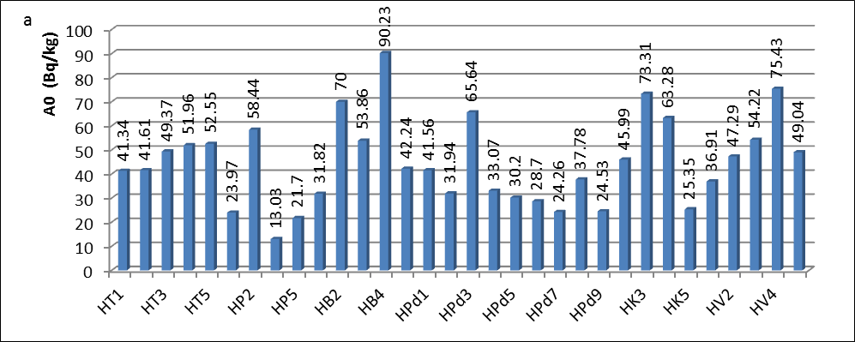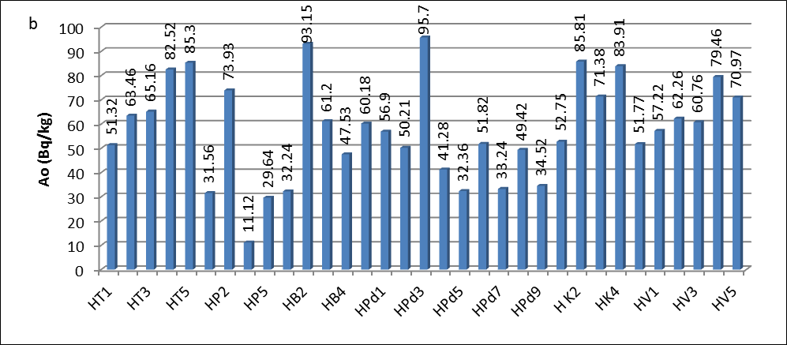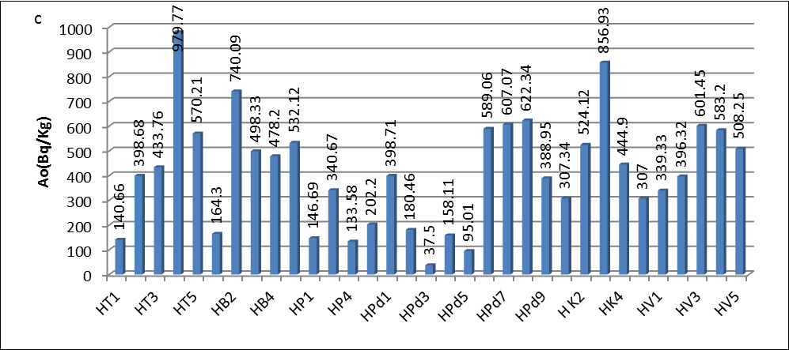
Fig.2. Activity concentration of ²²⁶Ra, ²³²Th and ⁴⁰K in soil samples: a. ²²⁶Ra,b. ²³²Th and c.⁴⁰K.

Table 1. Radium equivalent (Ra_{eq}), gamma-ray absorbed does, annual effective does,external and internalhazard index from the surface soil samples collected from Bolikhamxay province, Laos.
Sample  code | Ra_{eq}(Bqkg⁻¹) | Absorbed  Does rate  nGyh⁻¹ | Annual  Effective dose $E(mSv/y)$ | External hazard index (H_{ex}) | Internal hazard index (H_{in})
HT1 | 124.57±12.61 | 105.74±15.40 | 0.13± 0.02 | 0.34±0.04 | 0.45±0.06
HT2 | 160.27±17.05 | 139.98±18.43 | 0.17±0.02 | 0.44±0.05 | 0.55±0.07
HT3 | 172.91±18.07 | 151.80±18.68 | 0.19±0.02 | 0.48± 0.05 | 0.61±0.08
HT4 | 178.11±18.51 | 105.74±11.76 | 0.13± 0.02 | 0. 34± 0.04 | 0.45±0.06
HT5 | 214.44±24.23 | 187.79± 21.91 | 0.23± 0.03 | 0.59±0.07 | 0.73±0.09
HP1 | 79.37±9.26 | 68.50± 8.63 | 0.08±0.01 | 0.22±0.05 | 0.28±0.04
HP2 | 188.01±10.24 | 162.34±8.61 | 0.20± 0.02 | 0.51±0.02 | 0.67±0.09
HP4 | 73.36±26.11 | 65.27± 8.80 | 0.08±0.01 | 0.20±0.07 | 0.27 ±0.04
HP5 | 121.96±10.06 | 106.77±8.56 | 0.13±0.01 | 0.34±0.02 | 0.43±0.05
HB1 | 89.42±6.28 | 77.88± 8.30 | 0.10± 0.01 | 0.24± 0.02 | 0.33±0.04
HB2 | 255.01 ±33.87 | 226.07±28.63 | 0.28±0.03 | 0.70±0.08 | 0.89±0.12
HB3 | 220.84±28.27 | 199.14 ± 21.75 | 0.24 ±0.03 | 0.61±0.07 | 0.79 ±0.11
HB4 | 192.19±21.78 | 174.03±20.18 | 0.21±0.03 | 0.53±0.07 | 0.77 ±0.11
HB5 | 146.91±17.06 | 130.63±14.53 | 0.16± 0.02 | 0.40 ±0.04 | 0.52 ±0.06
HPd1 | 150.84±19.31 | 132.72± 14.42 | 0.16±0.02 | 0.41±0.05 | 0.53±0.07
HPd2 | 116.37±15.28 | 99.05±12.74 | 0.12±0.01 | 0.32±0.04 | 0.40±0.05
HPd3 | 227.88±38.91 | 189.44±25.83 | 0.23±0.03 | 0.62±0.08 | 0.83±0.11
HPd4 | 103.17± 17.93 | 88.48±9.69 | 0.11±0.01 | 0.28±0.03 | 0.37±0.05
HPd5 | 83.13±11.55 | 70.98± 8.91 | 0.09±0.01 | 0.23±0.03 | 0.31±0.04
HPd6 | 144.04±17.02 | 130.53±14.60 | 0.16±0.02 | 0.40±0.04 | 0.48±0.06
HPd7 | 167.23±19.36 | 153.89±16.79 | 0.19±0.02 | 0.47±0.05 | 0.56±0.07
HPd8 | 152.01±17.84 | 138.91± 14.45 | 0.17±0.02 | 0.42±0.05 | 0.52±0.06
HPd9 | 101.12±12.04 | 91.66±10.36 | 0.11±0.01 | 0.28±0.03 | 0.35±0.04
HK1 | 139.96±19.51 | 122.18±16.43 | 0.15±0.02 | 0.38±0.04 | 0.50±0.06
HK2 | 176.95±29.85 | 160.63±18.59 | 0.20±0.03 | 0.49±0.06 | 0. 72 ±0.09
HK3 | 235.37±32.41 | 214.52 ±29.15 | 0.26±0.03 | 0.65±0.08 | 0.85 ±0.11
HK4 | 214.41± 25.01 | 186.11± 21.12 | 0.23±0.03 | 0.59±0.08 | 0.76±0.08
HK5 | 120.87 ± 13.01 | 104.83 ± 12.12 | 0.13 ± 0.02 | 0.33 ± 0.04 | 0.40 ± 0.05
HV1 | 142.49±15.75 | 124.05±13.16 | 0.15±0.02 | 0.39±0.04 | 0.49 ±0.05
HV2 | 164.06±17.84 | 143.70±14.98 | 0.18±0.02 | 0.45±0.05 | 0.58 ±0.06
HV3 | 183.21±20.32 | 164.83±17.17 | 0.20±0.02 | 0.51±0.05 | 0.65 ±0.07
HV4 | 212.07 ±21.94 | 186.33 ± 19.9 | 0.23 ±0.03 | 0.58 ± 0.06 | 0.75 ±0.08
HV5 | 186.10±17.26 | 163.84± 20.83 | 0.20±0.02 | 0.51±0.06 | 0.64 ±0.07
Aver. | 158.75 ± 16.10 | 140.31 ±15.75 | 0.17 ±0.02 | 0.44 ±0.05 | 0.56 ±0.07
4. Conclusion
In this work the natural radioactivities in 33 surface soil samples collected from Bolikhamxay province were determined using a gamma ray spectrometer with HPGe detector. The average radioactivity concentrations of ²²⁶Ra and ²³²Th are 46.73±5.92 and 57.95±7.72 Bq/kg, which are higher than that of the world average values (35 Bq/kg and 30 Bq/kg) respectively . But activity concentrations of ²²⁶Ra and ²³²Th are less than the value average of Nghe An province [8], it shares borders with Bolikhamxay provinceof Laos. The activity concentration of ¹³⁷Cs was not found in any of samples from Bolikhamxay province, this means that it is lower than the minimum detection limit. The mean radium equivalent activity concentration, the mean external and internal hazard indices in the study areas were less than the world average [1].
References

[1] UNSCEAR United National Scientiﬁc Committee on the Effectsof Atomic Radiation Sources and Risks of Ionizing Radiation,Report to the General Assembly with Annexes, United Nations,New York, 2000.
[2] KarahanG,Bayulken A. Assessment of gamma dose rates around Istanbul (Turkey). J Environ Radioact 2000;47:213-21
[3] Erees FS, Aközcan S, Parlak Y, Çam S. Assessment of dose rates around Manisa (Turkey). Radiat Measure 2006;41:598‑601.
[4] Dabayneh K, Mashal L, Hasan F. Radioactivity concentration in soil samples in the southern part of the WestBank, Palestine. RadiatProt Dos 2008; 131: 265-271
[5] Abdel-Ghany H. Natural activities of ²³⁸U,²³²Th and ⁴⁰K in manganese ore. Am EnvSci 2010; 6: 90-94

[6] Yu, K.N., Guan, Z.J., Stokes, M.J. and Young, E.C.M.,The assessment of natural radiation dose committed to the Hong Kong people.Journal of Environmental Radioactivity 17,31.(1992)

[7] Beretka, J. and J. Matthew, 1985. Natural radioactivityof Australian building materials, industrial wastesand by products. Health Physics Journal, 48: 87-95.
[8] N.Q.Huy et al.,Natural radioactivity and external does assessment of surcface soils in Vietnam.Radiation Protection Dosimetry (2012), Vol. 151, No. 3, pp. 522–531.

∗Corresponding author. Tel.:84-912865869. Email:s.leuangtakoun@nuol.edu.la

