Facial synthesis and characterization of polypyrrole/zinc oxide (ZnO) nanorode and flower-like shape composites

**Nguyen Xuan Sang1*, Luu Thi Lan Anh2, Tran Thanh Thai3, Phan Trung Nghia4, and Vo Thach Son2**

*1Sai Gon University, 273 An Duong Vuong, ward 3, district 5, Ho Chi Minh City*

*2School of Engineering Physics, Hanoi University of Science and Technology, Hanoi*

*3Quy Nhon University, 170 An Duong Vuong, Quynhon, Binhdinh*

*4School of Chemical Engineering, Hanoi University of Science and Technology, Hanoi*

*Corresponding author:* Nguyen Xuan Sang

Email: [sang_nguyen_xuan@yahoo.com](mailto:sang_nguyen_xuan@yahoo.com)

Portal address: Saigon University, 273 An Duong Vuong, ward 3, district 5, Ho Chi Minh City.

Mobile: 84-904512337

**ABSTRACT**

Polypyrrole (PPy) nanocomposites reinforced with zinc oxide (ZnO) nanorod and nano flower are fabricated by chemical oxidative polymerization method using an ammonium per-sulphate (APS, (NH4)2S2O8) as an oxidizing agent. The polymer nanocomposite were characterized by X-ray diffractometer (XRD), scanning electron microscopy (SEM), and Fourier transform infrared (FTIR). The results were compared with pure as-prepared PPy. The SEM images of the nanocomposites show homogeneous dispersion characteristics and different morphologies of ZnO structures such as rod and flower-like shapes. In the FTIR spectra, composite samples showed characteristic peaks of PPy shifted to higher positions confirmed the interfacial interactions between ZnO and PPy matrix.

*Keywords*: PPy/ZnO nanocomposite; polymerization; FTIR; interconnection.

**1. INTRODUCTION**

Recently, polymer nanocomposites have attracted great interest owing to their novel properties derived from the successful combination of the characteristics of parent constituents into a single material. The unparallel advantage such as cost-effective processability, lightweight and tunable mechanical, electrical and optical properties for the diverse applications such as microwave absorption, bio- and gas sensors, super capacitors [1- 4].

Among the conjugated polymers, polypyrrole (PPy) is the most investigated conducting polymer because of its sizable electrical conductivity, ion-exchange capacity, hydrophobic nature, and so on. PPy can be synthesized in the form of powder, films, colloidal particles and composites in micro and nano sizes [5-7].

Semiconductor oxides (SMOs) are the most fascinating class of materials. Composites of  
conducting polymers and SMO micro/nanostructures are attracted a huge attention in modern science and  
technology due to their potential applications. Numerous attempts are going on to refine the methods of mixing organic polymers with SMOs. In almost cases some specific nature of association between the two components has been observed [8-10]. Amongst, ZnO has received considerable interest in the fabrication with PPy as hybrid materials because of its variety of applications in optoelectronic devices. The zinc oxide nanoparticles has received great attention because of its unique catalytic, electrical, electronic, and optical properties, as well as its low cost and extensive applications in diverse areas [11].

In this article, we report a facile synthesis route of PPy/ZnO nanocomposite by *ex situ* graft technique and study of their microstructural, morphological properties, and the interconnection of PPy and ZnO in the composite.

**2. EXPERIMENTAL**

***Hydrothermal synthesis of ZnO structure***

Nanocrystalline ZnO was synthesized by the one-step hydrothermal technique. In this work, HMTA (Aldrich) and Zn(NO3)2 (Merck) were used as initial chemicals without further treatment. We fabricated two ZnO samples with the [HMTA]/[Zn(NO3)2] ratio at 1:1 and 1:4, respectively. The resulting mixture was transferred to an autoclave for hydrothermal route at temperature 90 0C in 6 h. The products were collected and rinsed twice with absolute ethanol and distilled water and then dried in vacuum at 90 0C for 24h. Finally, a fine white powder was obtained.

***Synthesis of PPy/ZnO nanocomposite***

PPy/ZnO nanocomposite was synthesized by chemical oxidative polymerization technique using monomer pyrrole (C4H5N) and prepared ZnO NPs. Analytical grade ammonium per-sulphate (APS, (NH4)2S2O8) was used as an oxidizing agent. The chemical polymerization was carried out in a beaker by mixing 0.1M aqueous solution of pyrrole and 0.1M of APS in 1:1 ratio by volume. Then, specified volume of resulting ZnO product (*i.e.* 50 wt%, based on the monomer content) was added to the mixture. The polymerization was carried out at room temperature for a period of 2h. After termination of polymerization process, black precipitate obtained. The precipitate was filtered and washed several times successively by distilled water to remove any possible oligomers and dried in oven at 60 0C for 24 h to get PPy/ ZnO composite sample.

***Characterization and measurements***

The crystalline structure of the ZnO nanostructure was recorded with a X'Pert PRO, PANalytical-Phillip X-ray Diffractometer using the Cu-Kα radiation (λ=0.154056 nm). The FT-IR spectroscopy was used to characterize the chemical structure of the samples. For this purpose, a FT-IR nicolet 6700 thermo spectrometer (USA) with a resolution of 4 cm-1 was used in the range of 500 ÷ 4000 cm-1. The morphology of the obtained samples was characterized by SEM (FEI Quanta 200).

**3. RESULTS AND DISCUSSION**

Figure 1 showed the XRD patterns of ZnO prepared by hydrothermal method at different ratios Zn(NO3)2: HTMA. All samples were indexed to the hexagonal wurtzite structure. It can be seen that in the XRD patterns, there are peaks at 2θ = 31.71, 34.36, 36.196, 47.52, 56.58, 62.82 and 68.02 corresponding to (100), (002), (101), (102), (110), (103) and (201) diffraction planes of ZnO, respectively (JCPDS 36-1451). Additives we had the highest peak intensity at 2θ ≈ 36.20º, indicating that the ZnO was crystallized with preferably oriented (101) plane.

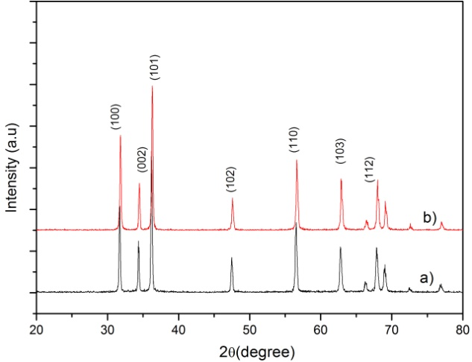

**Figure 1** XRD pattern with the ratios Zn (NO3)2:HTMA in hydrothermal processes: **a**) 1-1, **b**) 1-4

From X-ray diffraction diagram, we can determine the crystal size Debye-Scherrer formula below:

where d is the crystallite size, λ is the wavelength of diffracted ray, B is the half peak width (rad), θ is the angle of diffraction.

The average size of ZnO crystals is presented in Table 1. It shown that, when ratios Zn (NO3)2: HTMA increase from 1:1 and 1:4, crystallized with preferably oriented (101) plane. The average size of ZnO crystals is the biggest of when ratios Zn (NO3)2: HTMA =1:4 sample and about 37nm.

***Table 1*** *The average crystallite size of ZnO samples of [002] and [101]*

|  |  |  |  |
| --- | --- | --- | --- |
| ratios Zn (NO3)2: HTMA | I002/I101 | d002(nm) | d101(nm) |
| 1:1 | 0.3633 | 27.75 | 20.83 |
| 1: 4 | 0.3268 | 36.96 | 22.28 |

Surface morphologies of pure PPy, ZnO structures, and PPy/ZnO NPs composites were investigated by SEM technique, shown in Figure 2. First, fig. 2a shows pure as-prepared PPy with spherical shape with average diameter size of 300 nm. Fig. 2b and 2c shows ZnO structures with the different morphology as rod with size of 1 μm x 4 μm (thickness x length) and dandelion flower-like with needle size of 2 μm, respectively. Fig. 2d and 2e shows images of composites of PPy loaded with ZnO rode and flower-like shape, respectively.

The difference morphologies of ZnO, i.e. in rod and in flower shapes, were responsible by HMTA surfactant as a weak base and pH buffer. HMTA hydrolyses very rapidly in water, increasing the amount of HMTA that causes large OH-ions to form in a short period of time. The Zn2+ ions in the solution will precipitate rapidly in a high pH environment, and eventually lead to a rapidly decreasing amount of Zn2+ ions thereby hindering the development of flower-shaped ZnO.

Finally, fig. 2d and 2e shows the composition of PPy/ZnO composites whose ZnO structures were taken from samples whose images were in fig. 2b and 2c, respectively. As one can see in fig. 2d, they were interconnected forming more flat shape as a membrane. Irregularly-sized PPy particles linked together in clusters, grown on the surface of ZnO, and/or pop out to destroy the original structures of ZnO. One could explain the destruction of the structure of ZnO by the oxidation of APS. When ZnO powder is added in the process of PPy synthesis in APS environment which is a very strong oxidant that can melt out ZnO structures. Fig. 2e showed resulting product of flower-like ZnO and PPy. We can see that the ZnO shape does not change, closely enough, the inset showed the size of ZnO flower branches increases. In the polymerization process, PPy particles did stick on the branches of ZnO, making the flower branch size of ZnO much larger. These results initially indicated the strong interaction of ZnO and PPy. In order to study about level interactions of ZnO and PPy in composites, FTIR spectra of PPy and its composites need to be investigated.

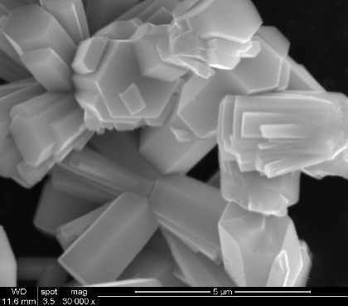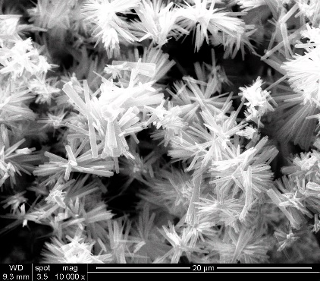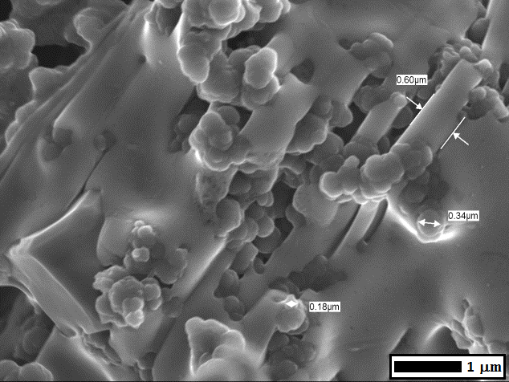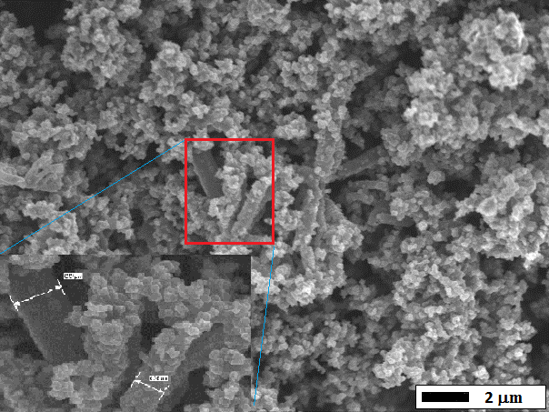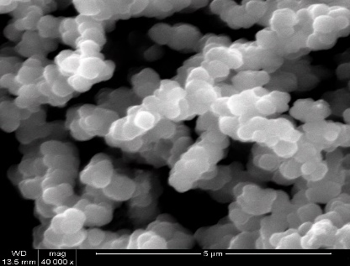

a)

b)

c)

d))

e)

**Figure 2** SEM images of (a) pure PPy, (b) ZnO rod, (c) ZnO dandelion flower-like, (d) Ppy-ZnO nanorod and (e) PPy-ZnO nano flower-like samples

Wavenumber (cm-1)

Wavenumber (cm-1)

Wavenumber (cm-1)

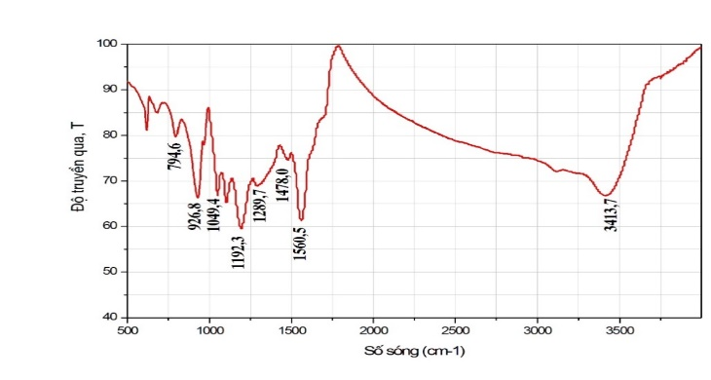

**a)**



Transmittance (%)

**b)**



Transmittance (%)

**c)**

Transmittance (%)

**(c)**

**Figure 3** The FTIR spectra **a**) pure PPy, **b**) Ppy/ZnO-rod and **c**) PPy/ZnO-flower composites.

Figure 3 shows the FTIR spectra in the range 500 – 4000 cm-1 of the pure PPy, Ppy/ZnO rod and PPy/ZnO flower nanocomposites. For pure PPy, all the characteristics peaks are observed at 794.6 cm1 (=C-H wagging), 926.8 cm1 (C-C out of phase), 1049.4 cm1 (=C-H in plane vibration), 1289.7 cm1 (C-C bond), 1478 cm1 (vibration of the pyrrole ring), 1560.5 cm1 (C=C bond) and 1699 cm1 (C=N bond). The peak at 3413.7 cm1 is assigned to presence of N-H stretching vibrations. The peaks observed in the present work matches well with the ones available in literature [11, 12] confirming the formation of PPy. The spectrum for Ppy-ZnO nanorod and PPy-ZnO nano flower nanocomposites showed some shifts in the wavenumber of PPy vibration modes, and changed in their intensities indicating that there have the interaction and connection between ZnO and PPy during the synthesis process. Table 2 showed comparison of vibration positions of PPy, PPy/ZnO composites from their FTIR spectra with reference.

**Table 2** *Observation of FTIR vibration modes in PPy and PPy/ZnO nanocomposites*

|  |  |  |  |  |  |  |
| --- | --- | --- | --- | --- | --- | --- |
| No. | Vibration mode | Wavenumber (cm-1) | | | | |
| Reference |  | Experimental results | | |
| PPy | | PPy/ZnO nano rod | PPy/ZnO nano flower |
| 1 | =C-H wagging | 794 | 794.6 | | 794.5 | 798,6 |
| 2 | C-C out of phase | 926 | 926.8 | | 925.1 | 934.2 |
| 3 | =C-H in plane vibration | 1044 | 1049.4 | | 1050 | 1053.5 |
| 4 | vibration of the pyrrole ring | 1190 | 1192.3 | | 1193.3 | 1200.7 |
| 5 | C-C bond | 1290 | 1289.7 | | 1291.5 | 1290.3 |
| 6 | vibration of the pyrrole ring | 1475 | 1478.0 | | 1475.2 | 1399.7 |
| 7 | C=C bond | 1558,4 | 1560.5 | | 1558.9 | 1573.7 |
| 8 | N-H stretching vibrations | 3415 | 3413.7 | | 3384.1 | 3389 |

**IV. CONCLUSION**

We have successfully synthesized PPy/ZnO composites with two types of hydrothermal ZnO morphologies, rod and flower-like shapes, respectively. SEM images showed the PPy homogenously distributed and attached on ZnO. For PPy/rode-ZnO composite, ZnO shape showed some degree of destruction and PPy covered fully on its surface. For PPy/flower-ZnO composite, ZnO flower branches were covered by PPy making its braches larger. FTIR spectra of composites showed PPy characteristic vibration mode positions shifted comparing to those of pure PPy, which indicated a good interconnection of ZnO and PPy. This resulting composites may delight a potential application as a negative electrode in dye sensitized solar cells (DSSCs).

**Acknowledgements:** This research is funded by Vietnam National Foundation for Science and Technology Development (NAFOSTED) under grant number 103.02-2016.87

**References:**

1. P. Colin, *Application of Conducting Polymers*; Edited by R. H. H. Neubert and H. H. Ruttinger, Dekker, New York, 2003.
2. M. M. Chehimi, E. Abdelijalil, *A study of the degradation and stability of polypyrrole by inverse gas chromatography, X-ray photoelectron spectroscopy, and conductivity measurements*, Synthetic Metals 145 (2004) 15.
3. D. T. McQuade, A. E. Pullen, T. M. Swager, *Conjugated Polymer-Based Chemical Sensors,* Chemical Reviews 100 (2000) 2537.
4. M. Gerard, A. Chaubey, B. D. Malhotra, *Application of conducting polymers to biosensors,* Biosensors and Bioelectronics 17 (2002) 345.
5. A. Reung-u-rai, A. Prom-jun, W. Prissanaroon-ouajai, *Synthesis of Highly Conductive Polypyrrole Nanoparticles via Microemulsion Polymerization*, *Journal of Metals, Materials and Minerals* 18 (2008) 27.
6. M. A. Chougule, *Synthesis and Characterization of Polypyrrole (PPy) Thin Films*, Soft Nanoscience Letters 01 (2011) 6.
7. B. Sevil and K. Zuhal, *Synthesis and characterization of polypyrrole nanoparticles and their nanocomposites with poly(propylene)*, Macromolecular Symposia 295 (2010) 59.
8. E. Ozkazanc, S. Zor, H. Ozkazanc, S. Gumus, *Preparation and characterization of polypyrrole/selenium composites,* Polymer Engineering and Science 53 (2013) 1131.
9. C. A. Ferreira, S. C. Domenech, P. C. Lacaze, *Synthesis and characterization of polypyrrole/TiO2 composites on mild steel* Journal of Applied Electrochemistry 31 (2001) 49.
10. M. Li, Y. Zhang, L. Yang, Y. Liu, *Excellent electrochemical performance of homogeneous polypyrrole/graphene composites as electrode material for supercapacitors,* Journal of Materials Science: Materials in Electronics 1 (2015) 485.
11. E. Dalas, P. Mougoyanni, S. Sakkopoulas, *Effect of ZnO concentration on the structure and charge transport in conductive polypyrrole /ZnO x% w/w composites with x = 10, 20, 30 and 40*, Romanian Journal of Physics 58 (2013) 354.
12. H. Shiigi, M. Kishimoto, H. Yakabe, B. Deore, T. Nagaoka, *Highly selective molecularity  
    imprinted overoxidized polypyrrole colloids: one step preparation technique* Analytical Science 18 (2002) 41.